Custom Built PCs Practice Interview

What brand, product, or service are you studying for your Value Analysis Project?
You said:
personal custom built pcs
ChatGPT said:
Great! So, within the custom-built PC market, who is the one most important “love group” you identified to study? This would be the group of customers who are most passionate and dedicated about custom PCs.
You said:
20 year old gamers
ChatGPT said:
Awesome choice! What do you know so far about these 20-year-old gaming enthusiasts? I'd love to hear about their key characteristics, like their lifestyle, any specific values or needs they have around custom-built PCs, and what drives their passion for this product.
You said:
customizability and getting exactly the parts they want.
ChatGPT said:
o, for these gamers, it's all about customizability and having full control over their setup to get precisely the parts that meet their gaming needs. That makes sense—having the freedom to pick and choose each component really speaks to their desire for a tailored experience.
Can you tell me more about why this level of customization is so important to them personally? What are they looking to achieve or feel by having a custom-built PC over a pre-built one?
You said:
don't know...that's why we're going to do this love group interview
ChatGPT said:
Perfect! That’s what makes these interviews so valuable. Through laddering and ZMET, you’ll get to uncover the deeper motivations and emotions behind their preference for custom builds.
When you're ready, I’ll jump into character as one of those 20-year-old custom PC gaming enthusiasts, ready to share why customization matters to me. Just let me know when to start!
You said:
what is your name?
ChatGPT said:
Hey! I’m Alex. Excited to chat about custom PCs with you!
You said:
okay perfect! Hi alex
ChatGPT said:

Hi there! Great to meet you! I’m all set to dive into why I’m so hooked on custom-built PCs. Where would you like to start?
You said:
describe for the transcript the first picture you brought in?
ChatGPT said:
The first picture I brought is of a workstation with a sleek, glowing RGB setup—think neon lights casting this awesome glow across a powerful PC tower and ultra-sharp monitors. For me, it represents that feeling of total control and personal expression. This setup isn’t just a computer; it’s my space, exactly how I imagined it.
You said:
can you create the picture for me so I can see what you're seeing?
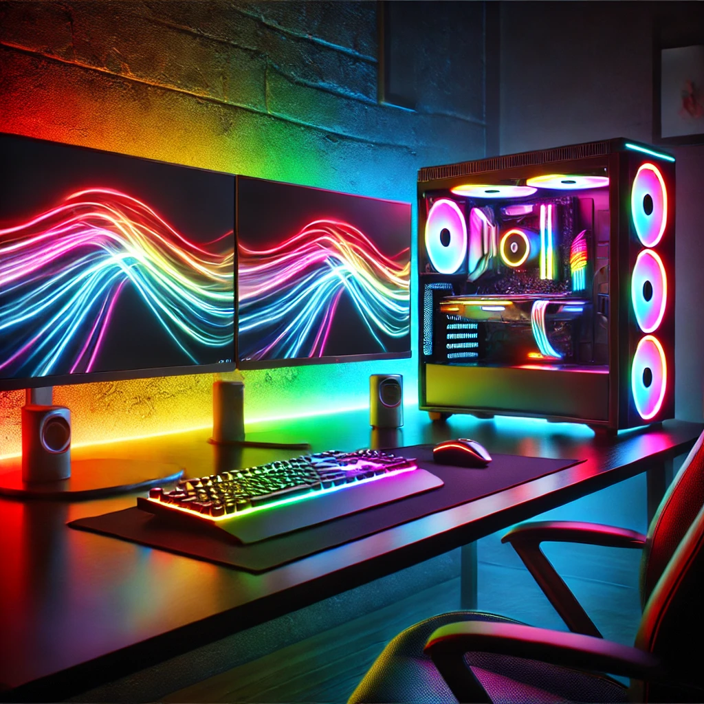

Here’s the image! This setup really brings out that feeling of control and individuality, with the RGB lights and organized layout creating a powerful vibe.
You said:
okay how does this picture represent your thoughts and feelings about custom built pcs.
ChatGPT said:
This picture really captures how custom-built PCs let me create my own world. The RGB lighting, chosen by me, feels like an extension of my personality, and the parts inside match exactly what I need for performance. It’s about more than just specs; it’s feeling like the PC is uniquely mine, built for my goals and experience.
You said:
okay can you help me understand what it is about custom pcs specifically that helps you create your own world?
ChatGPT said:
Sure! With custom PCs, I can pick each part—from the CPU to the graphics card to the cooling system—so everything works exactly how I need. That freedom gives me control over every aspect of my experience. It's like building a space that’s perfectly tuned to my gaming and creative style, where no detail is left to chance.
You said:
okay can you tell me a time you picked each part and what that was like for you?
ChatGPT said:
Absolutely! I remember last year when I built my first custom PC from scratch. I researched each component for hours—choosing the CPU felt like picking the brain, the GPU like the heart, and the RAM like the memory. Each part felt like a puzzle piece fitting into my vision. When it was finally all assembled, powering it on for the first time felt surreal, like I’d brought something alive that was truly mine.
You said:
Very cool...tell me about that moment when it first powered on?
ChatGPT said:
Oh, that first moment was electric. As soon as I pressed the power button and the lights flickered on, it was this instant rush of pride and excitement. I felt like I’d created something powerful, and seeing it come to life was almost surreal. It was like the PC recognized that I’d put in the work to build it. I just sat there for a few seconds, taking it in—feeling this mix of accomplishment and connection to something I’d made from scratch.
You said:
okay great! So you talked about freedom and control. how are those ides similar and different in expressing your thoughts and feelings about building custom pcs
ChatGPT said:
Freedom and control are definitely connected but come through in different ways. Freedom is all about choices—knowing I can pick any part I want, without restrictions, so I’m not stuck with something standard. It’s like the ultimate flexibility. Control, on the other hand, is the power to bring that vision together. Control means every decision I make directly impacts the final build; I’m shaping something exactly to my needs and tastes. Freedom is about possibilities, while control is about the precision in making those possibilities real.
You said:
very cool! thank you so much! So to make sure I understand. picking custom parts helps you create your own little world. And that is important to you because it gives you a sense of control and precision in the process of creating that own little world and it also gives you a sense of freedom because you can pick custom parts that aren't standard
ChatGPT said:

Yes, exactly! Building a custom PC lets me shape my own little world by giving me both the freedom to choose every component and the control to assemble it precisely to my vision. It’s that combination—freedom in choice and control in creation—that makes the whole experience so personal and rewarding for me. You’ve totally got it!
You said:
if you were going to give this picture a one or two word title as it represents your thoughts and feelings about building custom pcs, what would that title be?
ChatGPT said:
I’d call it “Masterpiece”—because it’s about crafting something uniquely my own, like a work of art I have total control over.
You said:
Cool, thank you for your input. What is the next picture you brought in? can you just describe what is in the picture for the transcript?
ChatGPT said:
The next picture is a close-up of a powerful graphics card, surrounded by other top-tier PC components. It’s all laid out neatly on a desk before assembly, with the tools I need beside it. To me, it shows the potential and excitement of building something high-performance from the ground up.
You said:
okay lets try that again, can you just describe what the picture is of and not what it represents yet?
ChatGPT said:
Sure thing! This picture shows a high-end graphics card, along with other PC components, all laid out on a desk. There are tools beside the parts, ready for assembly.
You said:
can you make that picture to show it to me?
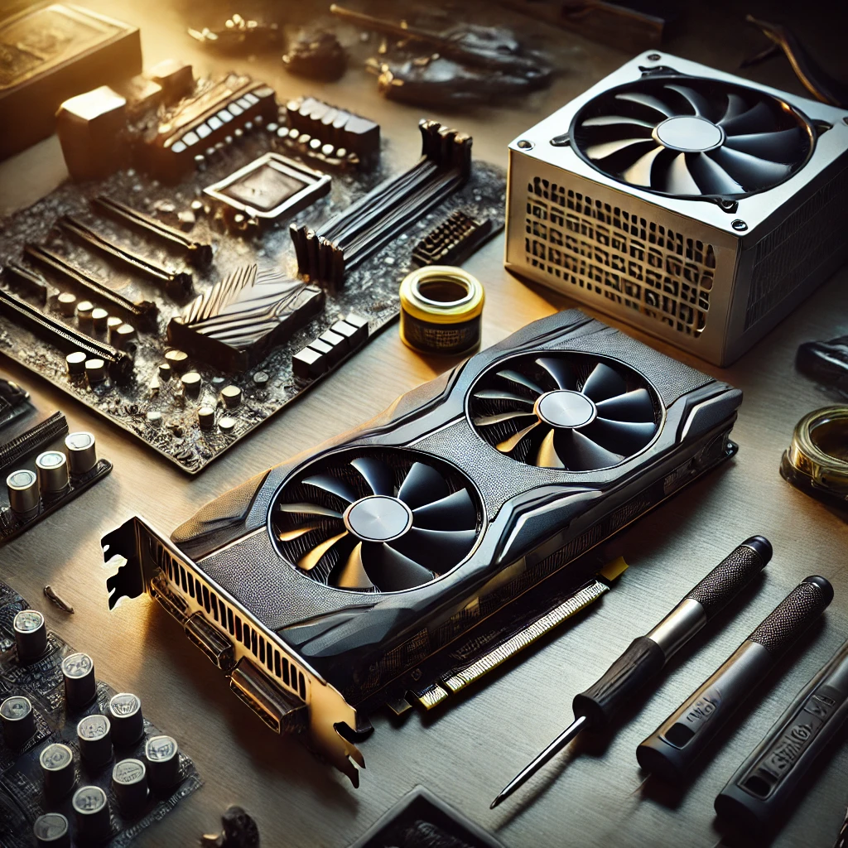
Here’s the picture! It captures the setup of components and tools perfectly, ready for that next step in building.
You said:
cool, how does this picture represent your thoughts and feelings about custom built PCs?
ChatGPT said:
This picture represents the anticipation and thrill of building a custom PC. Seeing all the parts laid out, especially powerful ones like the graphics card, gives me this sense of potential—like everything I need to create something amazing is right there, just waiting to come together. It’s a moment full of possibility.
You said:
Okay, lets say we could expand the frame of this image. what else would come into the image that would help me understand your thoughts and feelings about custom built PCs
ChatGPT said:
If we expanded the frame, you’d see my setup space—maybe with sketches of the build layout, a checklist of parts, and my phone open to forums or guides I’ve been following. There’d also be little details, like spare screws or zip ties, which show how invested I am in making everything perfect. These would capture the focus, excitement, and planning that go into each build.
You said:
If you could put yourself in that picture alex, where would you be?
ChatGPT said:
I’d be right there at the desk, leaning over the parts with a focused expression, maybe holding a screwdriver or examining the graphics card up close. It’s like I’m in the zone, fully immersed in the process and excited about each small step that brings the build to life.
You said:
can you make that image for me with the expanded frame and you in it?
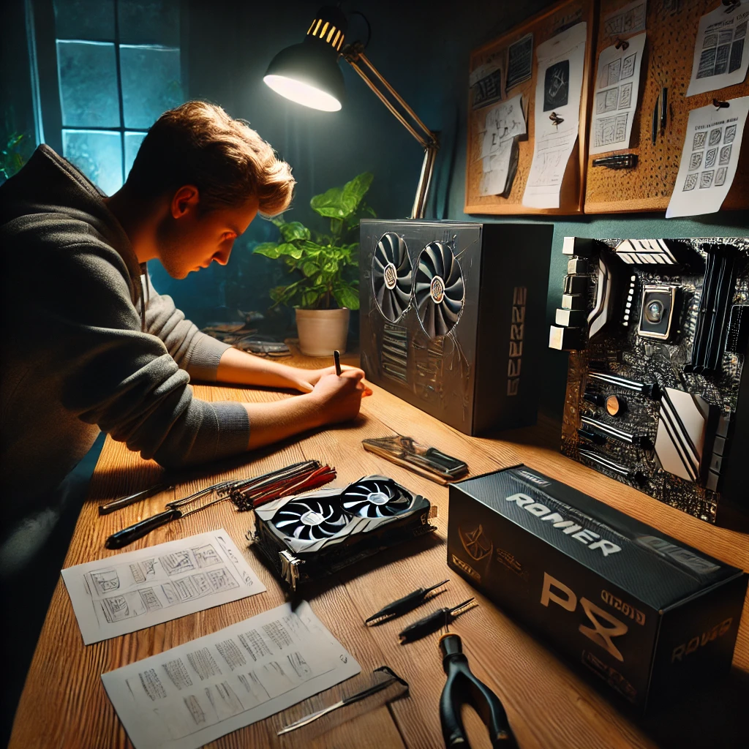

Here’s the expanded image! It really shows the focus and excitement of being immersed in the custom build process, surrounded by every essential part and tool.
You said:
cool...if we could create a thought bubble above your head like in a cartoon what would it say to describe your thoughts and feelings in this picture?
ChatGPT said:
The thought bubble would say, "This is it—everything’s coming together perfectly. Just a few more steps, and it'll be exactly as I envisioned." It captures the mix of excitement, focus, and satisfaction of seeing my plan take shape.
You said:
Okay great! If this picture were a picture in a cartoon with a before picture to the left and an after picture to the right, what would be in the before picture and the after picture to help me understand your thoughts and feelings about custom built PCs
ChatGPT said:
In the before picture, you’d see me browsing online, with parts scattered in different open tabs or windows. My expression would be one of curiosity and excitement, like I’m piecing together a puzzle in my head. The scene would capture that exploration phase—where everything’s an idea waiting to take shape.
In the after picture, the completed PC would be glowing with RGB lights, fully assembled on my desk, and I’d be sitting back, smiling with pride and satisfaction. This image would show the feeling of accomplishment and connection—like I’ve crafted something powerful and entirely my own.
You said:
can you show me those three pictures in a row?
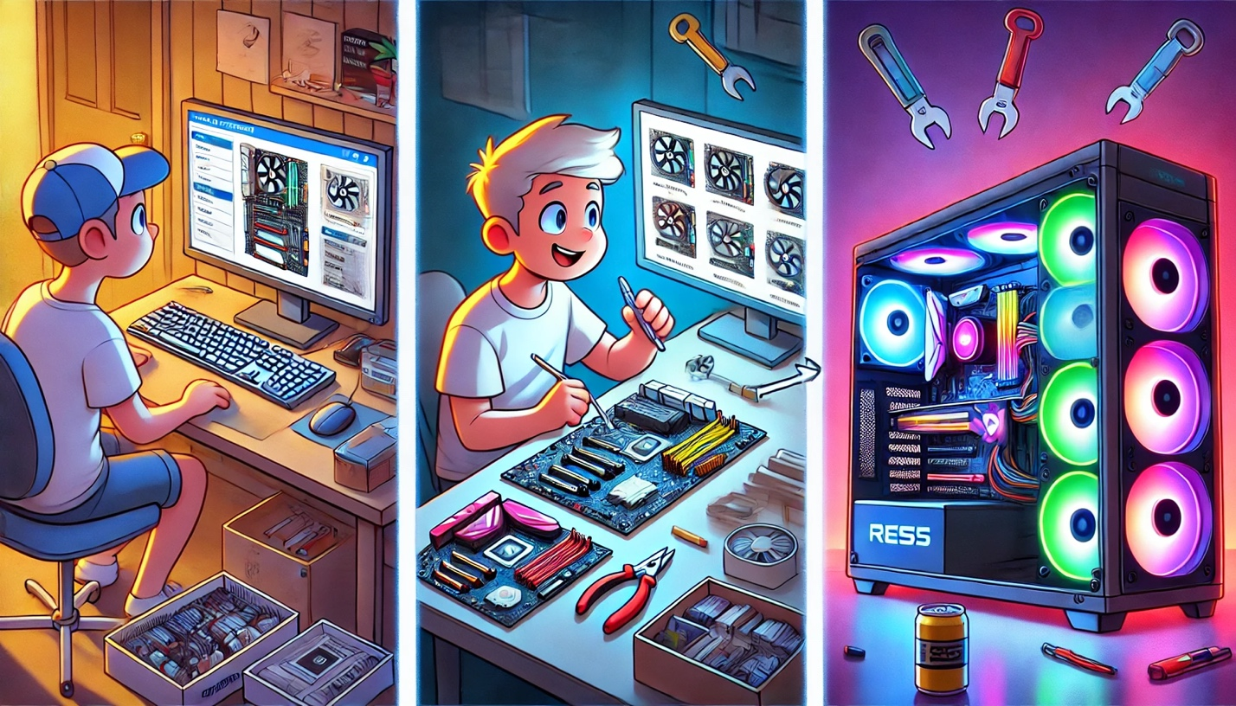
Here’s the cartoon-style image series showing the journey from planning to building to completion! It captures the excitement, focus, and final satisfaction that come with creating a custom-built PC.

