Learning with AI
A Student’s Complete Guide to Thinking Better with Artificial Intelligence
A Complete Prompt Library for Studying, Writing, and Critical Thinking

Mark Keith
Department of Information Systems Marriott School of Business, Brigham Young University
mark_keith@byu.edu | 1-801-674-5159
Version 1.2 | Last Edited: August 3, 2026
Developed collaboratively with Claude (Anthropic) and aligned with the AI Engagement Model Canonical Package 1.2.0. Feedback, questions, and suggestions are welcome.
© 2026 Mark Keith. Licensed under Creative Commons Attribution-NonCommercial 4.0 (CC BY-NC 4.0). You may share, adapt, and build on this work with attribution; for commercial use, please contact mark_keith@byu.edu.

Download: The Learn-with-AI Toolkit Plugin
59 skills covering everything from a 30-minute study session to a multi-year dissertation. Install once in Claude Cowork and Claude will automatically use the right skill for whatever you are working on.

Get it at: Download the Learn-with-AI Toolkit plugin

See Section 10 of this guide for what skills are, how they help, installation steps, and the full skill catalog.

Table of Contents
Download: The Learn-with-AI Toolkit Plugin 1
Table of Contents 2
1. Introduction: Why How You Use AI Matters More Than Whether You Use It 5
1.1 The Forty Percent Problem 5
1.2 The Illusion of Understanding 5
1.3 What This Guide Is 6
1.4 How to Use This Guide 6
2. The AI Engagement Model: Eight Ways to Think with AI 7
2.1 The Framework 7
2.2 The Passivity Trap (Modes 1–2) 8
2.3 The Partnership Zone (Modes 3–4) 9
2.4 The Agency Zone (Modes 5–8) 9
2.5 The Modes Are a Web, Not a Ladder 10
2.6 A Note on Personality and Mode Preferences 10
3. Setting Up Your AI Learning Environment 10
3.1 Why Setup Matters 10
3.2 Creating a Claude Project for Each Course 10
3.3 Uploading Your Course Materials 11
3.4 Connecting to the Web and Academic Research Tools 12
3.5 Using Claude with Other Tools 13
4. Entry Points: Start Where You Are 13
4.1 Entry Point A: "I Have 30 Minutes to Study" 13
4.2 Entry Point B: "I Need to Learn a New Concept" 15
4.3 Entry Point C: "I Need to Prepare for an Exam" 16
4.4 Entry Point D: "I Am Writing a Paper" 20
4.5 Entry Point E: "I Am Working on a Problem Set" 24
4.6 Entry Point F: "I Need to Build a Project" 27
4.7 A Note on Coding Assignments 27
5. The Complete Prompt Library 28
5.1 Socratic Tutoring Prompts 28
The Socratic Setup 28
The Teach-Back 28
The Concept Map 28
5.2 Retrieval Practice and Self-Testing Prompts 31
Flashcard Generator 31
Spaced Retrieval Session 33
The Blank Page Test 33
5.3 Critical Reading and Analysis Prompts 34
Active Reading 34
Reading Visualization 34
Case Analysis 35
5.4 Study Planning and Time Management Prompts 35
Semester Study Plan 35
Weekly Reset 35
Visual Study Dashboard 36
5.5 Writing Improvement Prompts 37
Paragraph-Level Feedback 37
Argument Strength Check 37
6. Building Visual and Interactive Learning Tools 38
6.1 Why Visuals Matter for Learning 38
6.2 Interactive Quiz and Flashcard Tools 39
Build a Quiz App 39
Concept Visualization 39
Comparison Matrix 40
6.3 Process and Concept Diagrams 40
Flowchart Builder 40
Timeline Visualization 40
6.4 Working with Claude’s Visual Output 40
7. Cross-Tool Workflows 41
7.1 Why Use Multiple AI Tools 41
7.2 The Second-Opinion Workflow 41
7.3 When to Use Which Tool 41
8. Honest Self-Assessment: Avoiding the Traps 42
8.1 The Illusion of Understanding (Revisited) 42
8.2 Recognizing When You Are Sliding into Passivity 42
8.3 The Confident Tone Trap (for Writing) 43
9. Academic Integrity and AI Disclosure 43
9.1 Using AI Honestly 43
9.2 How to Disclose AI Use 43
10. References 44
11. The Learn-with-AI Toolkit Plugin 45
11.1 What Skill Files Are and How They Help 45
11.2 How to Install the Toolkit 46
11.3 The 58 Skills at a Glance 46
Core Study and Retention (8 skills) 47
Reading and Notes (3 skills) 47
Exam Preparation (4 skills) 47
Writing Papers (8 skills) 47
Problem Sets (STEM) (5 skills) 48
Coding Assignments (4 skills) 48
Projects (2 skills) 48
Graduate-Specific (4 skills) 48
Self-Assessment and Metacognition (3 skills) 49
Time and Life Management (3 skills) 49
Academic Integrity (2 skills) 49
Career and Transition (4 skills) 49
Discipline-Specific (7 skills) 49
Master Orchestrator (1 skill) 49
11.4 How to Invoke Skills (You Don't Have to Memorize Any of Them) 50
11.5 Pairing with the Faculty Research Toolkit (For Graduate Students) 50
11.6 Updates and Feedback 51
Appendix A: The AI Engagement Model Quick Reference 51
Appendix B: Course Setup Checklist 51
Appendix C: The 30-Minute Study Session Template 52
Appendix D: Sample Custom Instructions for Different Course Types 52
D.1 STEM Courses 52
D.2 Writing-Intensive Courses 53
D.3 Case-Based Courses 53
D.4 Quantitative and Statistics Courses 54
D.5 Reading-Heavy Courses 54

1. Introduction: Why How You Use AI Matters More Than Whether You Use It

1.1 The Forty Percent Problem
In 2023, researchers at Harvard Business School ran an experiment with 758 management consultants at Boston Consulting Group. Every consultant got access to the same AI tool. Two groups emerged: one used AI with structure and intentionality, following specific protocols for when and how to engage the tool. The other group used AI however felt natural, with no particular system.
The structured group improved their work quality by 40%. The unstructured group performed 19% worse than consultants who did not use AI at all. Not "no improvement." Worse. The same tool, used differently, produced opposite outcomes (Dell’Acqua et al., 2023).
This finding matters for you because the same dynamic plays out in studying. There is a version of AI use that makes you a sharper, more capable student, and a version that quietly erodes your ability to think independently. Most students, through no fault of their own, are doing the second one.
A 2025 Microsoft study reinforced this concern. Lee and colleagues surveyed knowledge workers and found that higher confidence in AI correlated with less critical thinking. The people who believed they were best at using AI were often the ones whose analytical skills had deteriorated the most. They had no idea it was happening (Lee et al., 2025).
Meanwhile, 92% of college students now report using AI for academic work (Programs.com, 2025). Almost nobody has been taught how to use it well. That gap between adoption and understanding is what this guide addresses.

1.2 The Illusion of Understanding
Here is the core problem. When you read a clear, well-organized AI explanation, it feels like learning. Your brain registers recognition and fluency. You think, "I get it." But recognition is not recall, and fluency is not understanding. Close the chat window right now and try to explain what you just read to a friend. Most students cannot do it. They have experienced what psychologists call the "illusion of knowing."
The cognitive offloading research explains why. Risko and Gilbert (2016) showed that when external tools are available to handle cognitive work, people naturally shift effort to the tool. This is not laziness. It is how brains operate. Your brain is an efficiency machine, and if something else can do the thinking, your brain will happily let it. The Google Effect (Sparrow, Liu, and Wegner, 2011) demonstrated that knowing you can search for something reduces your effort to remember it. AI is the Google Effect on steroids. It does not just store facts for you. It thinks for you. And your brain adjusts accordingly.
The testing effect research (Dunlosky et al., 2013) points to the solution. The most effective learning strategy researchers have identified is retrieval practice: forcing yourself to recall information without looking at it. AI use, as most students practice it, is the exact opposite. It provides constant access to answers with zero retrieval effort.
The solution is not to stop using AI. It is to use AI in ways that force your brain to do the cognitive work. That is what this guide teaches.

1.3 What This Guide Is
This guide is a complete, field-tested system for using AI to learn more effectively than you could without it. Not by having AI do your work, but by having AI push your thinking further than you could push it alone.
The document serves a dual purpose. First, it is a guide you read and follow. Every section contains complete, copy-paste-ready prompts designed for specific learning situations. Second, it is a set of instructions for your AI. You can upload this entire document to a Claude project, and Claude will understand how to serve as your learning partner according to the principles described here.
Every recommendation exists because I watched it work (or fail) with real students. This is not theory assembled from a literature review. It is a workflow refined through building a university course on AI-assisted learning, running research studies on how students interact with AI, and extensive personal use across dozens of projects.
The guide is built on the AI Engagement Model (AIEM), a framework I developed to explain how a person, an AI tool, a task, and a context jointly shape an interaction. AIEM includes five parts: a co-production mechanism, dispositions, principles, eight observable engagement behaviors, and outcomes. It also includes a developmental loop called Becoming. This guide gives you prompts for practicing the eight behaviors while keeping learning, judgment, authorship, and verification with you.
What this guide is not: it is not a prompt engineering tutorial. It is not "10 tricks to get better answers from ChatGPT." It is not about getting AI to do your homework. If that is what you are looking for, this is the wrong document. This guide is about becoming a better thinker who happens to use AI as a thinking partner.

1.4 How to Use This Guide
There are three ways to use this document:
- Read it and follow the prompts. Each section contains complete prompts. Use them exactly as written to start, then modify as you develop your own style.
- Upload it to a Claude project. Create a new project in Claude, upload this document, and Claude will have persistent context about how to help you learn. This transforms every conversation from a one-off interaction into a session with a learning partner who understands the framework.
- Reference it as needed. Use the entry points (Section 4) to jump to whatever matches your current situation. Studying for an exam? Go to 4.3. Writing a paper? Go to 4.4. Have 30 free minutes? Go to 4.1.
The document recommends Claude specifically because of its visual interface features (called artifacts), extended thinking, and project-based context. But the principles transfer to any AI tool. Cross-tool workflows with Gemini and ChatGPT are covered in Section 7.
The fastest way to use this guide is to install the Learn-with-AI Toolkit (see Section 10). With the toolkit installed, Claude runs the workflows in this guide automatically — you ask for what you need in plain English, and the matching skill fires. Without the toolkit, you can still use every prompt in Sections 4–9 by copying them directly into Claude.

2. The AI Engagement Model: How Engagement Forms and Develops

2.1 The Framework
AI engagement is not a fixed property of a tool or a single prompt. It is a pattern co-produced by you, the AI tool, the task, and the context. Change the person, tool, task, or setting and the same words can lead to a different interaction. Strong engagement keeps you responsible for the purpose, important judgments, evidence checks, and what you learn from the work.
The formation tree shows the whole model. Surrounding conditions represent the co-production mechanism. Five dispositions form the roots: Intellectual Humility, Internal Locus of Evaluation, Investment in Process, Tolerance for Ambiguity, and Tinkering Disposition. Six principles form the trunk: Authorship, Productive Friction, Calibrated Trust, Dialogue, not Transaction, Voice Preservation, and Reflection. The eight modes form the branches. Learning, Judgment, Agency, Voice, and the carefully bounded long-run idea of Flourishing form the fruit. Becoming is the recurring cycle through which reflective practice can strengthen future engagement. One conversation or score cannot prove that a disposition changed.

# | Mode | What It Looks Like | Your Brain Is… | Behavioral grouping
1 | Oracle | “What’s the answer to this question?” | Consuming | Passivity
2 | Production Assistant | “Write this essay / Summarize this chapter” | Delegating | Passivity
3 | Tutor | “Help me understand this. Don’t just tell me—ask me questions.” | Learning | Partnership
4 | Collaborative Problem-Solver | “Here’s my thinking so far. What am I missing?” | Co-reasoning | Partnership
5 | Verification Agent | “I think this is right, but check my work.” | Checking | Agency
6 | Creative Expander | “Five approaches I haven’t considered?” | Exploring | Agency
7 | Critical Challenger | “Attack my argument. Where is it weakest?” | Stress-testing | Agency
8 | Problem Setter | “Am I even asking the right question?” | Reframing | Agency

The mode table names the behavior branch of AIEM. Passivity, Partnership, and Agency are useful groupings of engagement patterns, not fixed identities or a ranking of people. Any mode can be wise or unwise depending on the task, timing, stakes, and control you retain.
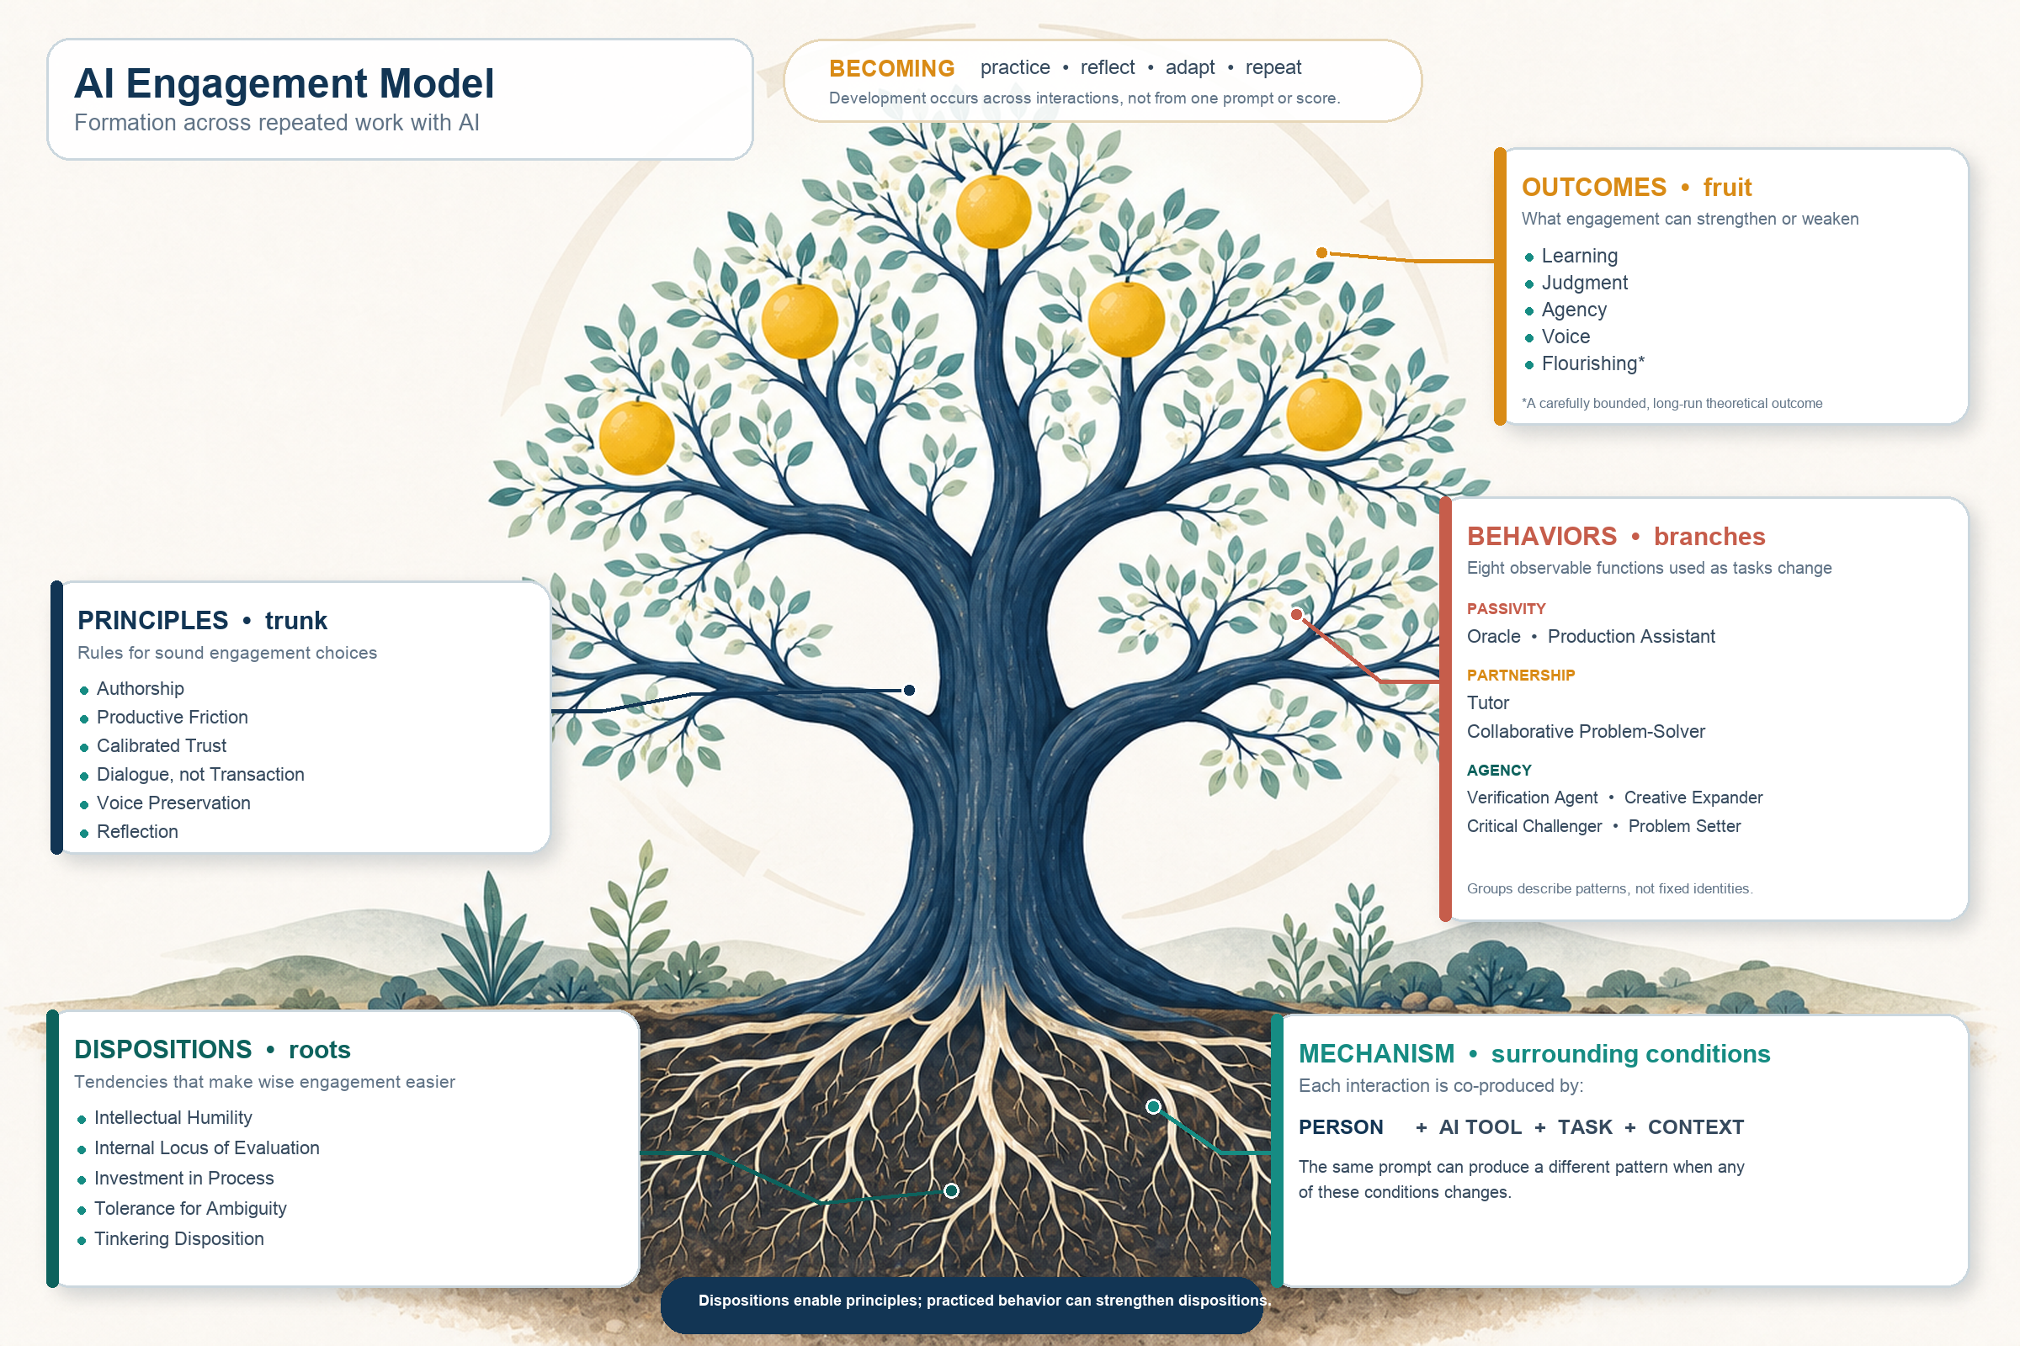
Figure 1. The AI Engagement Model formation tree. Architecture explains why engagement differs; the Becoming loop explains how reflective practice may change future engagement.
Why the model has four layers. Who you are shapes the rules you hold, the rules you hold shape how you actually engage with AI, and how you engage shapes what happens to your skills. That chain, dispositions to principles to behaviors to outcomes, is the oldest architecture in the study of character: Aristotle described it as stable disposition producing practical wisdom producing right action, and modern psychology's best-tested model of behavior (the Theory of Planned Behavior) confirms the same sequence empirically. Each layer rests on the one below it, which is why this guide works on your habits and rules, not just your prompts: change the lower layers and the behavior, and eventually the outcomes, follow.
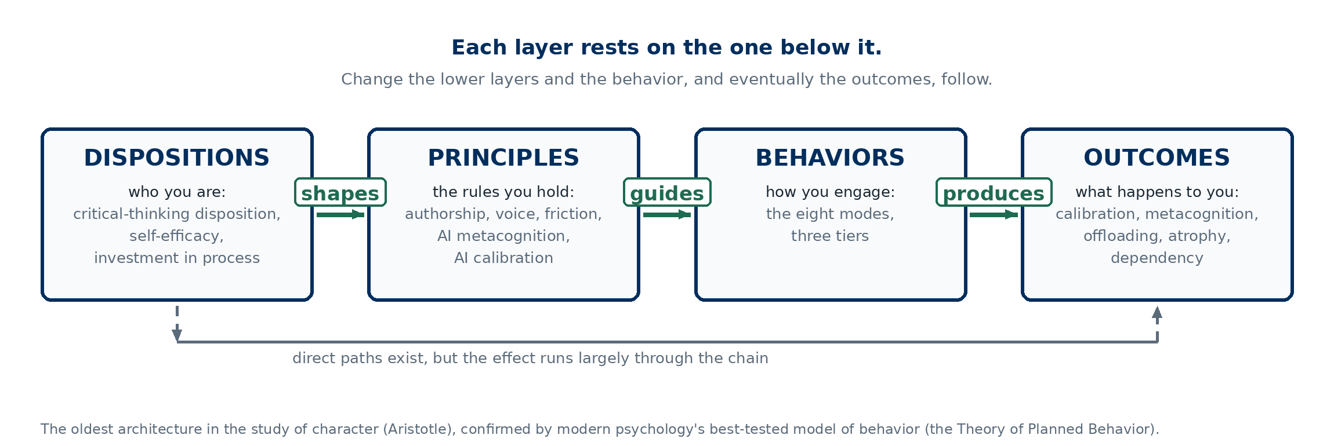
The four layers as a chain. The tree above shows what belongs to each layer; this diagram shows the direction: change the lower layers and everything downstream follows.

2.2 The Passivity Trap (Modes 1–2)
Most students live in Modes 1 and 2. Mode 1 (Oracle): you ask a question, AI gives an answer, you accept it. Mode 2 (Production Assistant): you ask AI to produce something (write an essay, summarize a chapter, solve a problem) and you submit or use the output with minimal modification.
These modes have their place. Sometimes you genuinely just need a quick answer. Sometimes you need a rough draft to react to. The problem is when these are your only modes. When Oracle and Production Assistant are all you know, every AI interaction becomes an exercise in cognitive offloading. Your brain never does the hard work. And the hard work is where learning happens.
Dell’Acqua and colleagues did not classify participants with AIEM. Their result supports a narrower lesson: access to a strong AI tool did not guarantee better work, and performance depended on how people used it and whether the task sat inside the tool's capability boundary. AIEM gives you a language for inspecting those choices without claiming that the study measured the eight modes.
A practical test: after your last AI conversation, could you explain the topic to someone without reopening the chat? If not, you were probably in Mode 1 or 2.

2.3 The Partnership Zone (Modes 3–4)
Mode 3 (Tutor): You ask AI to teach you, but you insist on active engagement. Instead of "explain photosynthesis," you say "I think photosynthesis works like this [your understanding]. Where am I wrong?" The AI becomes a Socratic partner, and your brain does the constructing.
Mode 4 (Collaborative Problem-Solver): You bring your own reasoning to the table. Instead of "solve this case study," you say "here is my analysis of this case. I think the core issue is X because of Y and Z. Push back on my reasoning and help me see what I am missing." The AI is not doing the thinking. You are thinking together.
Chi and Wylie's (2014) ICAP framework helps explain why constructive and interactive activity can support deeper learning than passive reception. AIEM is not a relabeling of ICAP, and a mode name alone does not prove that learning occurred. The useful question is whether the conversation made you explain, retrieve, connect, test, or revise ideas.

2.4 The Agency Zone (Modes 5–8)
These are the modes where you are in the driver’s seat.
Mode 5 (Verification Agent): You do not trust AI output by default. You check it. You ask "what sources are you drawing on?" and "are you sure about that number?" Parasuraman and Manzey (2010) showed that automation bias, the tendency to trust automated systems too much, is one of the most persistent cognitive failures in human decision-making. Students are especially vulnerable because AI output looks authoritative and polished.
Mode 6 (Creative Expander): You use AI to break out of your own thinking patterns. "Give me five completely different approaches to this problem, including ones from disciplines I have not studied." You are using AI’s breadth to expand your own creative range.
Mode 7 (Critical Challenger): You deliberately ask AI to attack your ideas. "What is the strongest argument against my position?" This is the opposite of confirmation bias. You are using AI to find the holes in your own thinking before a professor or exam does.
Mode 8 (Problem Setter): You pause before solving and improve the question, goal, constraints, or success criteria. 'I have been treating this assignment as an X problem. What evidence would show that it is really a Y problem?' Schön (1983) called this 'problem setting' and described it as a central professional skill. It is not a universally highest mode. A well-framed task may need Verification, Tutoring, Collaboration, or Production next.

The Learn-with-AI Toolkit (Section 10) helps you select and sequence modes on purpose. It does not ban Oracle or Production Assistant. It asks you to notice when a low-effort mode would remove the thinking, judgment, or practice the task is supposed to develop.

2.5 The Modes Are a Web, Not a Ladder
No behavioral grouping is always better. A student writing a quick email draft may fit Production Assistant. A student studying for a final exam may combine Tutor, Verification Agent, and Critical Challenger. The skill is knowing which mode fits the situation and being able to change modes deliberately.
The dependency relationships matter. You cannot do meaningful Verification (Mode 5) until you understand the material well enough to spot errors, which requires Tutor mode (Mode 3) first. You cannot do meaningful Critical Challenge (Mode 7) until you have your own argument to challenge, which requires Collaborative Problem-Solving (Mode 4) first.
The goal of this guide is to expand your repertoire. You should be able to choose a mode that fits the moment, change modes when the task changes, and explain why the sequence protected your learning and judgment.

2.6 A Note on Personality and Mode Preferences
People do develop preferences, but one conversation cannot diagnose personality or character. Use the five dispositions as reflection questions instead. Did you admit uncertainty? Keep final judgment with yourself? Care about the process? Stay with ambiguity long enough to examine it? Try and compare another approach? Repeated practice on those questions can make wise engagement easier over time.

2.7 Prompt AI to Use AIEM
Do not ask an AI to 'use AIEM' and assume it knows what that means. Give it a brief that preserves your role and names the mode you need right now. The image below is a quick reference. The complete template is also written beneath it so you can copy it into any major AI assistant.
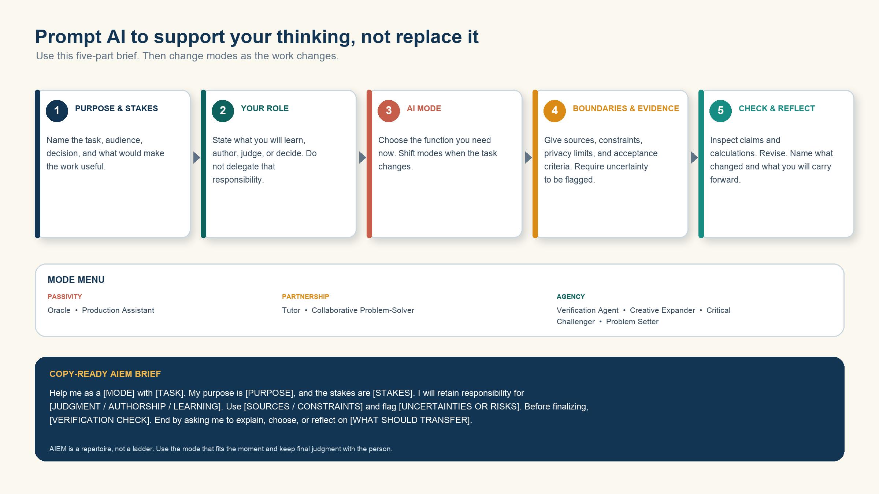
AIEM prompting quick reference.
Copy-ready student brief: Help me as a [MODE] while I learn [TOPIC OR SKILL]. My purpose is [LEARNING OUTCOME], and the stakes are [WHY IT MATTERS]. I will retain responsibility for [EXPLAINING / SOLVING / JUDGING / WRITING]. Use [COURSE MATERIALS OR SOURCES] and follow [CONSTRAINTS]. Flag uncertainty instead of guessing. Before finalizing, check [CLAIMS, SOURCES, CALCULATIONS, OR LOGIC]. End by asking me to explain, retrieve, choose, or perform [WHAT SHOULD TRANSFER] without your help.

3. Setting Up Your AI Learning Environment

3.1 Why Setup Matters
The way you set up your AI environment influences whether you default to Oracle mode or choose a pattern that fits the learning task. A blank chat window with no context invites "give me the answer" interactions. A well-configured project with your course materials, custom instructions, and persistent context makes tutoring, collaboration, challenge, and verification easier to sustain. This section teaches you to build an environment that supports better thinking.

3.2 Creating a Claude Project for Each Course
Claude’s project feature gives you persistent context across conversations, so you do not have to re-explain your course, your level, and your goals every time. Create a separate project for each course. Name it clearly (e.g., "BIO 301 - Molecular Biology - Spring 2026").
When you create a project, you can add custom instructions that shape every conversation. Use the following prompt as your starting custom instructions. It establishes Claude as a learning partner rather than an answer machine:

PROMPT
You are my learning partner for [Course Name]. Your job is not to give me answers. Your job is to help me think.

Rules for every conversation:
1. Before answering any question, ask me what I already know about the topic and what I think the answer might be.
2. When I ask you to explain something, explain it, then immediately ask me to restate it in my own words.
3. If I ask you to solve a problem, do not solve it. Instead, ask me to identify the first step, then guide me through my own solution.
4. When I make an error, do not just correct me. Ask me a question that helps me find the error myself.
5. At the end of every conversation, ask me to summarize what I learned and what I am still confused about.
6. If I try to get you to just give me the answer, push back gently and redirect me to think through it myself.
7. Periodically check: "Can you explain this without looking at our conversation?" If I cannot, we need to work on it more.

My current level: [beginner / intermediate / advanced] in this subject.
My learning goals this semester: [list goals].
My next exam or major assignment: [date and topic].

Each rule serves a specific cognitive purpose. Rule 1 forces retrieval before new information. Rule 2 uses the generation effect. Rule 3 prevents cognitive offloading. Rule 4 applies the testing effect. Rule 5 builds metacognition (Flavell, 1979). Rule 6 prevents sliding into Oracle mode. Rule 7 tests for genuine understanding versus the illusion of understanding.

3.3 Uploading Your Course Materials
What to upload and why: your syllabus (so Claude knows the course structure, grading, and schedule), your textbook chapters or key readings (so Claude can reference specific content rather than generating from general knowledge), past exams or problem sets if available (so Claude can generate practice at the right level), and assignment descriptions as they are assigned.
The principle is simple: a Claude project with your actual textbook uploaded gives you fundamentally better help than a blank chat where Claude guesses what your course covers. Claude can "see" everything in your project. The more relevant material you give it, the more specific and accurate its assistance becomes.
After uploading your materials, use this prompt to make sure Claude understands the landscape:

PROMPT
I have uploaded my course materials for [Course Name]. Please read through them and tell me:
1. What are the main topics this course covers?
2. Based on the syllabus, what is the structure and progression of the course?
3. What are the most important concepts I need to master?
4. Based on the difficulty level and the readings, what is this course expecting me to be able to DO by the end (not just know, but do)?
5. Are there any connections between topics that I should pay attention to as the semester progresses?

Do not summarize everything. Focus on giving me a map of the course that helps me see how the pieces fit together.

3.4 Connecting to the Web and Academic Research Tools
Claude can search the web for current information, but students writing papers need published, citable academic research. Claude’s training data includes published papers, but it cannot reliably provide exact citations or confirm that a paper exists. Two MCP plugins solve this problem: Consensus and Scholar Gateway. They search actual academic databases in real time.
When to use broad web search: current events, recent statistics, news, non-academic sources, practical how-to information. When to use Consensus or Scholar Gateway: finding published research to cite, verifying that a study exists and is cited correctly, discovering the state of research on a topic, building literature reviews.

PROMPT
I am writing a paper on [topic] for [course]. I need to find published academic research to support my arguments. Please use Consensus and Scholar Gateway to search for:
1. The most-cited foundational papers on this topic
2. Recent papers (last 3-5 years) that represent the current state of knowledge
3. Any papers that specifically address [your specific angle]

For each paper, give me: authors, year, journal, the key finding, and why it matters for my argument. Organize thematically, not chronologically.

Note: Consensus and Scholar Gateway require a Claude Pro subscription and MCP plugin setup.

3.5 Using Claude with Other Tools
Skills install once. Unlike custom instructions or project uploads, skills from the Learn-with-AI Toolkit (Section 10) are available in every Cowork conversation you start — you don't have to set them up per course.

You can extend your AI learning environment beyond the chat interface. Claude can browse the web to find current information and access online resources. For group study, students can use Claude in Slack channels to facilitate discussions, generate study questions, or summarize group conversations. You can also ask Claude to help build study schedules, track assignments, and create task lists, which is particularly useful for the 30-minute study session workflow in Section 4.1.
Keep these integrations simple. The goal is not to build a complicated technology stack. It is to make it easy to reach for AI in a structured way when you sit down to study.

4. Entry Points: Start Where You Are
Not every study session is the same. Sometimes you have 30 minutes between classes. Sometimes you need to master a concept for tomorrow’s exam. Sometimes you are staring at a blank page with a paper due. This section gives you a starting point for each situation, with complete prompts you can use immediately.

4.1 Entry Point A: "I Have 30 Minutes to Study"
Skill: study-session-planner. With the toolkit installed, say "I have 30 minutes — help me make it count" and this workflow runs automatically.
The daily micro-study session. This is possibly the most valuable habit a student can build. Thirty minutes of focused AI-assisted study, done consistently, produces more learning than sporadic multi-hour cramming sessions. The key is structure: you need a plan before you open the chat, not after.
Step 1: Build your study plan.

PROMPT
I have 30 minutes to study right now. Here is what I am working with:
- Course: [name]
- Topics I need to cover: [list upcoming topics or chapters]
- My next exam/assignment: [date and description]
- Topics I feel weakest on: [list]
- Topics I covered in my last study session: [list, if applicable]

Build me a focused 30-minute study plan. Do not just list topics. Tell me:
1. What to focus on in these 30 minutes (pick ONE or TWO concepts, not five)
2. What specific activity to do for each (retrieval practice, concept mapping, problem-solving, etc.)
3. A 5-minute self-test at the end to check whether I actually learned it
4. What to focus on in my NEXT 30-minute session based on what we cover today

Prioritize depth over breadth. I would rather truly understand one concept than superficially skim three.

Step 2: Execute the plan with active learning. Follow the plan Claude generates, using the Socratic learning prompts from Section 5. The 30-minute constraint is a feature, not a limitation. It forces focus and prevents the "I will study for four hours" sessions that usually devolve into passive re-reading.
Step 3: Close with a self-test.

PROMPT
My 30 minutes are up. Before I close this conversation, I want to test whether I actually learned what we covered. Please:
1. Ask me 3-4 questions about what we just studied. Do NOT give hints. I need to recall this from memory.
2. After I answer each one, tell me what I got right, what I got wrong, and what I should review next time.
3. Rate my understanding on a scale of 1-5 and explain your rating.
4. Give me ONE specific thing to review before my next study session.

Engagement Plan modes: This entry point primarily uses Mode 3 (Tutor) and Mode 5 (Verification). The self-test at the end practices retrieval, which is the single most effective learning strategy identified in the research (Dunlosky et al., 2013).
Make it visual. If you are studying a topic that involves processes, relationships, or categories, ask Claude to build you an interactive study tool before the self-test. This turns your 30-minute session from a text conversation into a hands-on learning experience.

PROMPT: Visual Study Tool
Before we wrap up, build me an interactive visual artifact for what we just covered. Depending on the topic, this could be:
- An interactive diagram showing how the concepts relate to each other
- A quick 5-question quiz with a score tracker so I can test myself
- A decision tree or flowchart if we covered a process
- A comparison table if we covered multiple related ideas

Make it something I can interact with, not just a static image. I want to use it as a quick review tool before my next session.

4.2 Entry Point B: "I Need to Learn a New Concept"
Skills: socratic-tutor, teach-back-grader, misconception-hunter. With the toolkit installed, say "teach me [concept] Socratically" or "quiz my understanding of [concept]."
You have encountered a concept in lecture or readings that you do not understand. The temptation is to ask AI "explain X" and read the explanation. That is Oracle mode, and it produces the illusion of understanding. Instead, use this workflow.
Step 1: State what you already know (even if it is wrong).

PROMPT
I need to understand [concept]. Here is what I think I know so far:
[Write your current understanding, even if it is incomplete or wrong. Include what you think the concept means, how it connects to other things you have learned, and where your understanding breaks down.]

I am not confident in this understanding. Please:
1. Tell me what I got right.
2. Tell me what I got wrong or what is incomplete.
3. Do NOT just give me a corrected version. Ask me questions that help me figure out where my thinking went wrong.
4. Once I have corrected my understanding, ask me to explain the concept back to you in my own words.

Starting with your own understanding matters because it activates retrieval, surfaces misconceptions early, and gives AI a specific starting point rather than generating a generic explanation. Research on the "generation effect" shows that attempting to produce an answer before receiving instruction produces deeper learning than receiving instruction first.
Step 2: Build connections.

PROMPT
Now that I have a better understanding of [concept], help me connect it to the bigger picture:
1. How does this concept relate to [other concept from the same course]?
2. Can you give me a concrete, real-world example that illustrates this concept?
3. What is the most common misconception students have about this concept, and why is it wrong?
4. If I had to explain this to a friend who has never taken this course, what analogy would work best?
5. What would a test question about this concept look like?

Step 3: Test yourself honestly.

PROMPT
I think I understand [concept] now. Test me. Ask me a series of questions, starting easy and getting progressively harder. Include:
1. A basic definition question
2. An application question (use the concept in a new scenario)
3. An analysis question (compare it to a related concept or identify when it does and does not apply)
4. A synthesis question (combine it with another concept to solve a new problem)

Do not give me hints. If I get stuck, ask me a guiding question instead of telling me the answer. I want to know if I REALLY understand this or if I am just recognizing it because we just discussed it.

The four question types follow Bloom’s Taxonomy (Bloom et al., 1956; Anderson and Krathwohl, 2001) from remembering to creating. If you can handle the synthesis question, you genuinely understand the concept.
Step 4: Build an interactive concept explorer. Once you have worked through the concept conversationally, ask Claude to create a visual artifact that lets you explore it interactively. This is especially powerful for concepts with multiple parts, relationships, or stages.

PROMPT: Interactive Concept Explorer
Now that we have worked through [concept], build me an interactive visual that helps me study it. I want:
1. A diagram or visualization showing the key components and how they connect.
2. The ability to click on any component to see its definition and role.
3. At least one interactive element: a quiz question, a drag-and-drop exercise, or a "what happens if you change this?" simulation.
4. A color-coded legend so I can see the structure at a glance.

This should be something I can come back to as a study reference, not just a one-time explanation.

Engagement Plan modes: Mode 3 (Tutor) throughout, with Mode 5 (Verification) in the self-test phase.

4.3 Entry Point C: "I Need to Prepare for an Exam"
Skills: exam-blueprinter, practice-exam-generator, spaced-exam-plan, exam-post-mortem. With the toolkit installed, say "my exam is in X weeks — build me a study plan" and the relevant skills chain automatically.
Exam preparation is where AI has the most potential to help or hurt. The wrong approach (asking AI to summarize everything) produces a false sense of readiness. The right approach (retrieval practice, interleaved testing, and targeted weak-spot drilling) can dramatically improve performance.
Step 1: Map the exam territory.

PROMPT
I have an exam coming up in [course] on [date]. The exam covers [topics/chapters]. I have uploaded my course materials to this project.

Please help me create an exam preparation plan:
1. Based on the course materials, what are the most important concepts I need to know?
2. Which topics are most likely to appear on the exam (based on emphasis in the syllabus, readings, and any past exams I have uploaded)?
3. Rank the topics by my likely difficulty level, based on our previous conversations. Where am I strongest? Where am I weakest?
4. Create a study schedule between now and the exam date. Prioritize my weakest areas and use spaced repetition (come back to topics on different days, not all at once).
5. For each study session, specify what I should DO, not just what I should read.

Step 2: Practice with generated exam questions.

PROMPT
Generate a practice exam for [course/topic]. Make it realistic:
1. Match the format my professor uses (based on the past exams I uploaded): [multiple choice / short answer / essay / problem-solving / case analysis / mix]
2. Include [number] questions
3. Cover the full range of topics on the exam
4. Include at least 2-3 questions that require combining multiple concepts (these are the ones students usually miss)
5. Make the difficulty level match what I would actually see on the exam, not easier

Do NOT show me the answers yet. I will work through this and then come back to check my work.

Step 3: Review honestly.

PROMPT
Here are my answers to the practice exam: [paste answers].

Grade me honestly:
1. For each question, tell me if I am right or wrong and explain why.
2. For wrong answers, do not just give me the correct answer. Explain the specific concept I misunderstood and ask me a follow-up question to check whether I now understand it.
3. For right answers, tell me if my reasoning was solid or if I got the right answer for the wrong reason.
4. At the end, identify the 2-3 topics where my understanding is weakest and suggest what I should study next.
5. Generate 3 more questions specifically targeting my weak areas.

Step 4: The stress test.

PROMPT
I think I am ready for this exam. Prove me wrong.
1. Ask me the 5 hardest questions you can think of on this material.
2. Include at least one question that combines concepts from different parts of the course.
3. Include at least one question where the obvious answer is wrong (a common trap or misconception).
4. Do not help me. No hints. If I cannot answer, that tells me where I still need to study.

Step 5: Build an interactive practice exam. Instead of just reading questions and answers in the chat, ask Claude to build a full interactive exam experience. This is one of the most effective ways to use Claude’s visual interface for exam preparation.

PROMPT: Interactive Practice Exam
Build me an interactive practice exam as a visual artifact for [course/topic]. Include:
1. A timed exam interface that shows one question at a time.
2. A mix of question types matching my professor's format: [multiple choice / short answer / problem-solving].
3. A running score tracker.
4. After each question, show whether I was right or wrong and explain why.
5. At the end, show a results dashboard: my overall score, performance by topic, and the specific areas I need to review.
6. A "retry missed questions" button that lets me practice just the ones I got wrong.

Make it feel like a real exam, not a casual quiz. I want to practice under realistic conditions.

The screenshots below show what a practice exam artifact looks like in action. Claude generated this timed statistics exam with multiple choice questions, immediate feedback, and explanations for wrong answers.
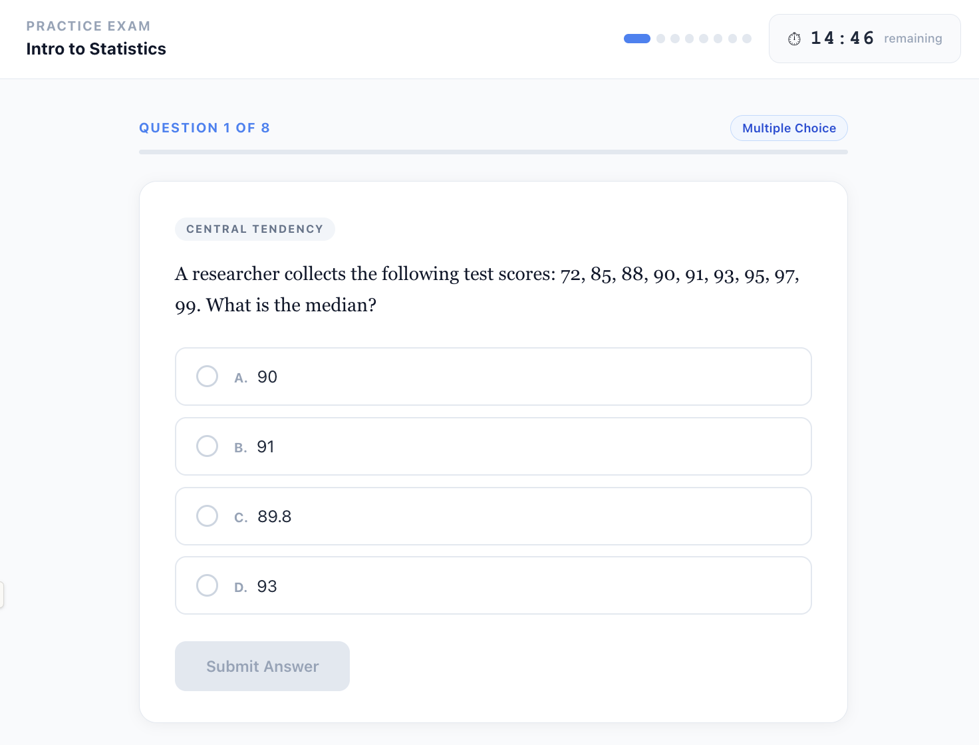
Figure 2. Sample interactive practice exam: a timed statistics question with multiple choice answers.
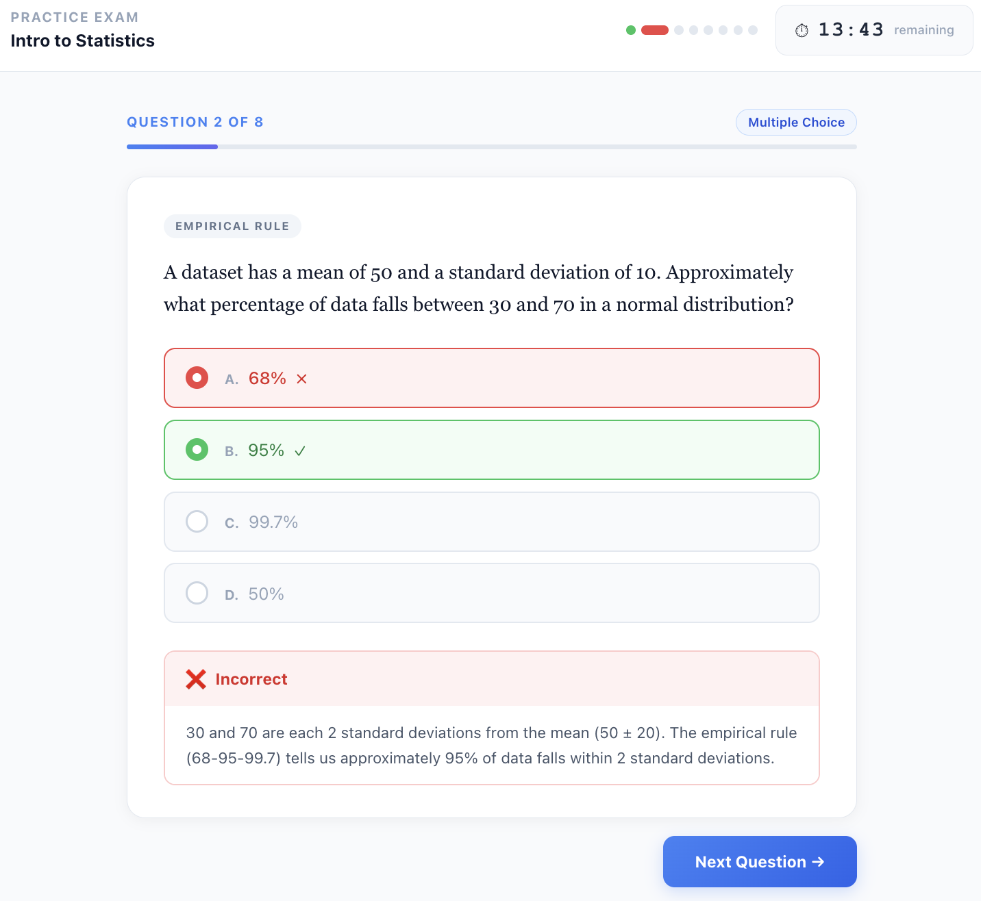
Figure 3. After submitting an answer, the exam shows whether you were right or wrong and explains the correct reasoning.
Engagement Plan modes: Mode 3 (Tutor) for concept review, Mode 7 (Critical Challenger) for the stress test, Mode 5 (Verification) for self-assessment.

4.4 Entry Point D: "I Am Writing a Paper"
Skills: paper-outliner, thesis-sharpener, evidence-collector, paragraph-editor, argument-strength-checker, voice-preserver. With the toolkit installed, say "help me outline my paper" or "sharpen my thesis" to run the matching workflow.
Student paper writing is where Consensus and Scholar Gateway become essential. The workflow moves from understanding the assignment through research, outlining, drafting, and revision. At every stage, you are thinking, not just consuming AI output.
Step 1: Understand the assignment deeply.

PROMPT
I have a paper due for [course]. Here is the assignment description: [paste it].

Before I start writing, help me understand what is really being asked:
1. What is the core question or task? (State it in one sentence.)
2. What does my professor actually want to see? (Based on the assignment description, what would distinguish an A paper from a B paper?)
3. What common mistakes do students make on assignments like this?
4. What skills or concepts from the course is this assignment designed to test?
5. What is the implied argument structure? (Is this a compare/contrast? A cause/effect analysis? A policy recommendation? An argument for a position?)

I want to understand the assignment before I start researching or writing.

Step 2: Research with academic sources.

PROMPT
I need to find published academic research to support my paper on [topic]. Please use Consensus and Scholar Gateway to search for:
1. Key foundational papers on [topic]
2. Recent research (last 5 years) that represents current thinking
3. Papers that specifically address [your specific argument or angle]
4. Any papers that argue AGAINST my position (I need to address counterarguments)

For each paper: authors, year, journal, key finding, and how I might use it in my paper.

Important: I need real, published, citable papers. If you are not certain a paper exists, say so. Do not fabricate citations.

Step 3: Build an outline before drafting.

PROMPT
Based on my research, here is my thesis: [state your thesis].

Help me build a detailed outline:
1. What is the logical flow of my argument? What needs to come first, second, third?
2. For each section, what is the main point and what evidence supports it?
3. Where should I address counterarguments?
4. Where is my argument weakest? What section will be hardest to write convincingly?
5. Does the overall structure make sense, or should I reorganize?

Push back if my structure has logical problems. I would rather fix them now than after I have drafted 10 pages.

Once you have a working outline, ask Claude to visualize your argument structure. This makes logical gaps and structural weaknesses visible in a way that a text outline cannot.

PROMPT: Argument Map
Build me an interactive argument map for my paper as a visual artifact. Based on the outline we just developed:
1. Show my thesis at the top.
2. Show each major section as a branch, with its main claim and supporting evidence.
3. Show where counterarguments fit and how I address them.
4. Color-code the strength of each section: green for well-supported, yellow for adequate, red for needs more evidence.
5. Draw the logical connections between sections so I can see the flow of the argument.

I want to be able to click on any section to see the details. This should help me spot where the structure is weak before I start drafting.

Here is what a generated argument map looks like. This sample was built for an English Composition essay on replacing letter grades with pass/fail. Notice how the color coding immediately reveals which arguments are strong, which need more evidence, and where the counterarguments hit hardest.
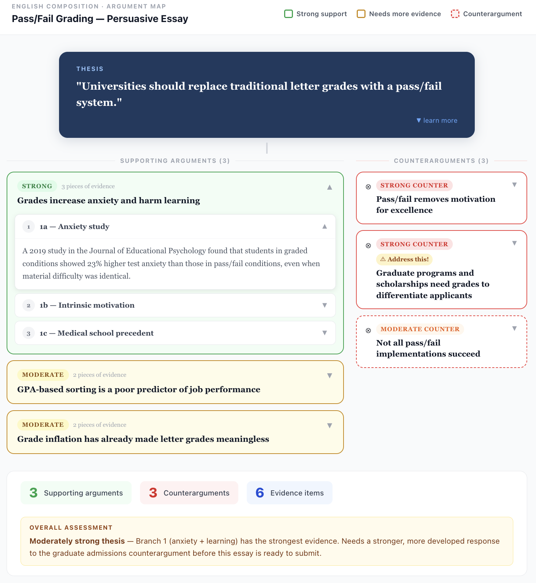
Figure 4. Sample interactive argument map for a persuasive essay. Supporting arguments are color-coded by strength (green = strong, yellow = moderate). Counterarguments appear on the right in red. Each element expands on click.
Step 4: Draft with your own thinking first.

PROMPT
I am ready to draft [section name]. Here is what I want to argue in this section: [state your argument in your own words, even if rough].

Help me develop this into a well-written section:
1. First, tell me if my core argument is clear and logical.
2. Suggest how to strengthen the argument with evidence from my research.
3. Help me write the first paragraph. Then I will take over and draft the rest, and you can review what I produce.
4. Do NOT write the entire section for me. I need to do the writing. You can help me think through the argument and improve my drafts.

The order matters: you write first, then use AI to critique and improve. The inverse (AI writes, you edit) is Mode 2 and produces weaker learning and weaker papers.
Step 5: Revise with critical eyes.

PROMPT
Here is my complete draft: [paste draft].

Review it critically. I want honest feedback, not encouragement:
1. Is my thesis clear and well-supported throughout?
2. Where is the argument weakest? Where would a professor push back?
3. Are there logical gaps or unsupported claims?
4. Is my use of evidence effective? Am I citing sources appropriately?
5. Where is the writing unclear, wordy, or unfocused?
6. Does the conclusion actually follow from the evidence I presented?
7. What grade would you give this draft and why? What would I need to do to improve it by one full letter grade?

Engagement Plan modes: Mode 4 (Collaborative Problem-Solver) for outline and argument development, Mode 7 (Critical Challenger) for revision, Mode 5 (Verification) for citation checking.

4.5 Entry Point E: "I Am Working on a Problem Set"
Skills: problem-coach, worked-example-generator, derivation-walker, error-teacher, proof-coach. With the toolkit installed, say "coach me through this problem" (do not give me the answer) to run problem-coach.
Quantitative courses (math, statistics, physics, economics, accounting, finance) often involve problem sets where the answer is a specific number. The temptation to paste the problem and ask for the answer is strongest here. But the entire point of problem sets is the practice of solving, not the answers themselves.
Step 1: Attempt the problem yourself first. This is non-negotiable. Before you open Claude, spend at least 5 to 10 minutes trying the problem. Write down your approach, even if you get stuck. Identify exactly where you get stuck. This matters because it activates your own problem-solving pathways and gives Claude a specific point to help with.
A common question: how do I actually "show my work" to an AI? You have several options, and the best one depends on how you are working:
- Photograph your handwritten work. If you solve problems on paper (which I recommend for math and physics), take a photo and upload it directly to Claude. Claude can read handwritten work, including equations, diagrams, and scratch notes. This is often the fastest method and the most natural for quantitative problem-solving.
- Screenshot your screen. If you are working in an online homework system, a spreadsheet, or a calculator app, take a screenshot and upload it. On Mac, press Command+Shift+4 to capture a selected area. On Windows, press Windows+Shift+S. Claude can read the image and understand what you are working on.
- Let Claude see your screen directly. If you use Claude in Chrome (available from the Claude desktop app), Claude can read whatever is on your screen. This is especially useful when you are working in an online platform and want Claude to see both the problem and your progress without switching windows. Open Claude in Chrome, navigate to your homework or problem set, and ask Claude to read the page.
- Type it out step by step. If your work is short or purely algebraic, you can type each step directly into the chat. Use plain text for math (e.g., "x^2 + 3x = 15, so x^2 + 3x - 15 = 0"). Claude understands standard math notation even without LaTeX formatting.
- Copy and paste from your working environment. If you are working in a spreadsheet, a Jupyter notebook, or a statistics program, copy the relevant output and paste it into the conversation. Include both your formulas or code and the results.
The method matters less than the habit. The point is that Claude sees your reasoning process, not just the problem statement. That way, Claude can identify exactly where your thinking went off track rather than generating a solution from scratch.

PROMPT
I am working on a problem from [course]. Here is the problem: [paste problem or upload a photo/screenshot].

Here is what I have tried so far: [show your work: type it, paste it, or upload a photo of your handwritten work].

I got stuck at [describe where you got stuck and why].

Please do NOT solve this for me. Instead:
1. Look at my approach so far. Am I on the right track, or did I take a wrong turn somewhere?
2. If I went wrong, ask me a question that helps me see where.
3. If I am on the right track but stuck, give me a hint about the NEXT step only. Not the full solution. Just the next step.
4. After I work through it, I will show you my solution and you can check it.

Step 2: Check and deepen understanding.

PROMPT
Here is my complete solution: [paste your solution].

Check my work:
1. Is the answer correct?
2. Is my method correct, or did I get the right answer by accident or through a flawed approach?
3. Is there a more elegant or efficient way to solve this?
4. What concept or skill is this problem testing?
5. Generate a similar problem (slightly harder) for me to practice. Do not give hints.

Step 3: Build pattern recognition.

PROMPT
I have now solved several problems on [topic]. Help me see the bigger picture:
1. What are the main problem types I am encountering in this topic?
2. For each type, what is the general approach or strategy?
3. How do I know which approach to use when I see a new problem?
4. What are the common traps or errors students make with these problem types?
5. Give me one problem that looks like one type but is actually another (a disguised problem). These are the ones that appear on exams.

Step 4: Visualize the problem-solving process. For problems that involve multi-step processes, formulas, or decision trees, ask Claude to build an interactive visual that shows how the pieces fit together. This is especially useful for statistics, physics, and economics where the same framework applies to many different problems.

PROMPT: Problem-Solving Visualizer
Build me an interactive visual artifact for solving [type of problem] in [course]. I want:
1. A decision tree or flowchart that shows: "Given a problem like X, here is how you decide which approach to use."
2. For each approach, show the steps with formulas and what each variable represents.
3. Include a worked example I can step through interactively (show/hide each step).
4. Common mistakes or traps highlighted in red at the steps where students typically go wrong.
5. If relevant, an interactive calculator where I can plug in values and see how changing one variable affects the result.

This should be a reference tool I can use when practicing additional problems on my own.

AIEM modes: Tutor for guided problem-solving, Verification Agent for checking work, and Problem Setter for recognizing problem types.

4.6 Entry Point F: "I Need to Build a Project"
Skills: project-scoper, project-planner. With the toolkit installed, say "scope my project" or "break this project into tasks."
Longer-term assignments like group projects, research projects, design projects, and capstone work require sustained collaboration with AI over multiple sessions. The key is to use the same Claude project for every work session so context accumulates.

PROMPT
I have a [project type] for [course]. Here is the assignment: [paste description].

The project is due [date] and involves [scope: individual/group, deliverables, etc.].

Help me plan this project:
1. Break it down into major phases with milestones.
2. For each phase, what are the key decisions I need to make?
3. What are the riskiest parts (where students usually run into trouble)?
4. Create a week-by-week timeline from now to the due date.
5. What should I do in my FIRST work session to build momentum?

Before you plan, ask me any questions you need to understand the project better. I would rather answer questions now than realize we missed something later.

4.7 A Note on Coding Assignments
Skills: code-explainer, code-reviewer-teacher, assignment-scaffolder, debug-coach. With the toolkit installed, say "review my code like a TA," "debug this with me," "explain what this code does," or "scaffold this assignment."
If you are taking a course that involves programming, AI can be an extraordinarily effective learning partner for debugging, understanding error messages, and working through algorithmic thinking. The same principles from this guide apply: show your code and your reasoning, ask for hints rather than solutions, and test your understanding by explaining your code back to Claude before asking it to check.
That said, coding courses present unique challenges around AI use that are beyond the scope of this document. The boundaries between "learning with AI" and "having AI write your code" are murkier than in other disciplines, and your professor likely has specific policies about which tools you can use and how. Courses that teach programming will almost certainly address AI engagement directly. Follow your instructor’s guidance, and apply the engagement plan framework (particularly Modes 3 through 5) to stay on the learning side of the line.

5. The Complete Prompt Library
This section provides the full prompt library organized by learning activity. Each prompt makes your role visible and supports a mode or sequence that fits the learning task. Use the prompts as written or adapt them to your courses and needs.

5.1 Socratic Tutoring Prompts
Skills: socratic-tutor, teach-back-grader, concept-map-builder. These three workflows are skills in the Learn-with-AI Toolkit. With it installed, you can skip the long prompts below — trigger them with plain-English requests.

The Socratic Setup
PROMPT
I want you to teach me [topic] using the Socratic method. Here are your rules:
1. Never give me the answer directly. Instead, ask me questions that lead me to discover the answer.
2. Start by asking me what I already know about [topic].
3. When I make an error, do not correct me. Ask a question that exposes the flaw in my reasoning.
4. When I get something right, push me deeper. "Why does that work?" "What would happen if...?" "Can you think of a case where that would not be true?"
5. Only give me a direct explanation if I have been stuck for 3+ exchanges and am getting frustrated. Even then, explain ONE piece, then go back to questions.
6. At the end, ask me to explain the entire concept back to you from memory.

The Teach-Back
PROMPT
I just learned about [topic]. I am going to try to teach it to you as if you know nothing about it. Listen to my explanation and then:
1. Point out any errors or misconceptions in my explanation.
2. Identify anything important that I left out.
3. Tell me which parts I explained clearly and which parts were confusing.
4. Ask me follow-up questions about the parts I seemed least confident about.
5. Rate my understanding: would a professor be satisfied with this explanation?

The Concept Map
PROMPT
I need to understand how the concepts in [chapter/unit] relate to each other. Let us build a concept map together:
1. Ask me to list the key concepts (from memory, not from the textbook).
2. For each concept, ask me how it connects to the others.
3. When I miss a connection or make a wrong one, ask me to think about it again.
4. Once we have the map, identify any concepts I seem shaky on and drill into those.
5. After we are done, build an interactive concept map as a visual artifact. I want to be able to click on each concept to see its definition, click on each connection to see how the concepts relate, and see color coding that shows which ones I understand well (green) versus which need more work (yellow or red).

The images below show a sample concept map Claude generated for introductory cell biology. Nodes are color-coded by type (blue for structures, green for molecules, orange for processes), and clicking any node reveals its definition and connections.
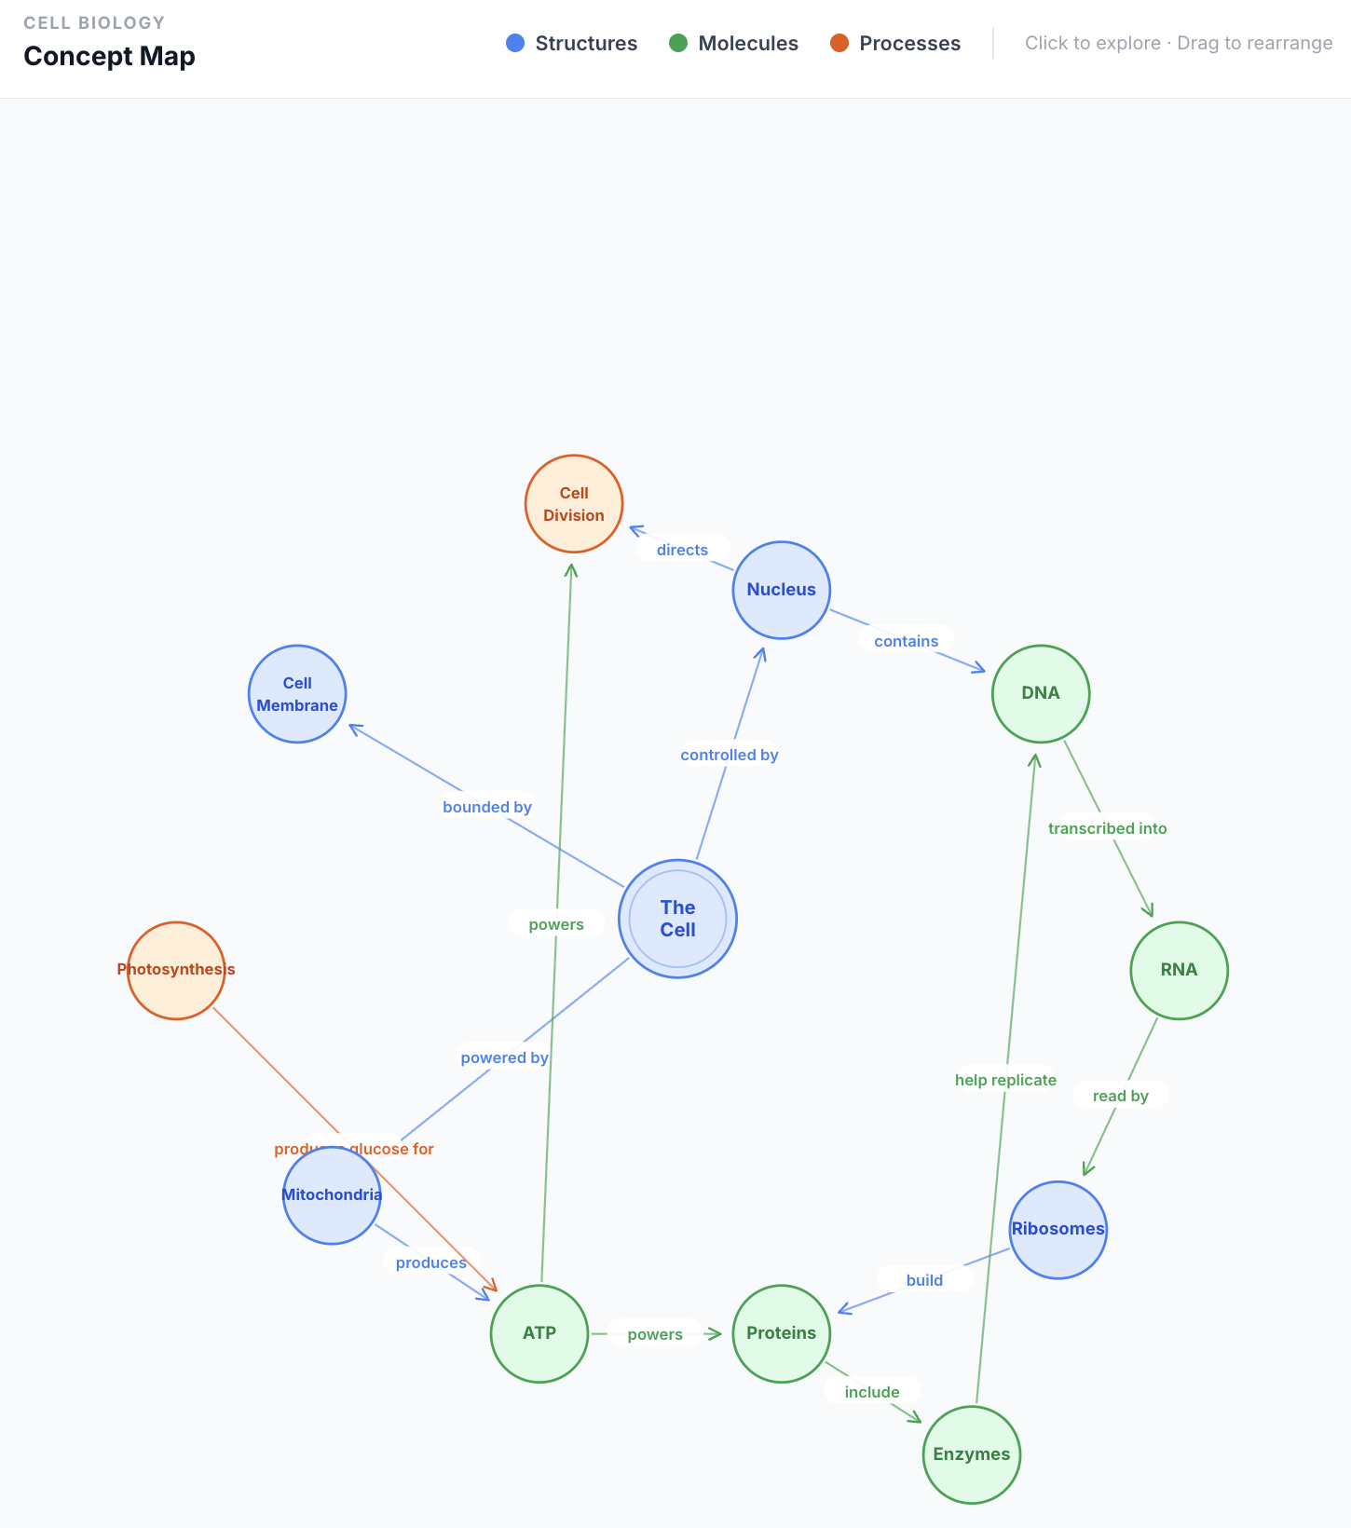
Figure 5. Sample interactive concept map for Biology 101 cell biology. Nodes are draggable and color-coded by category.
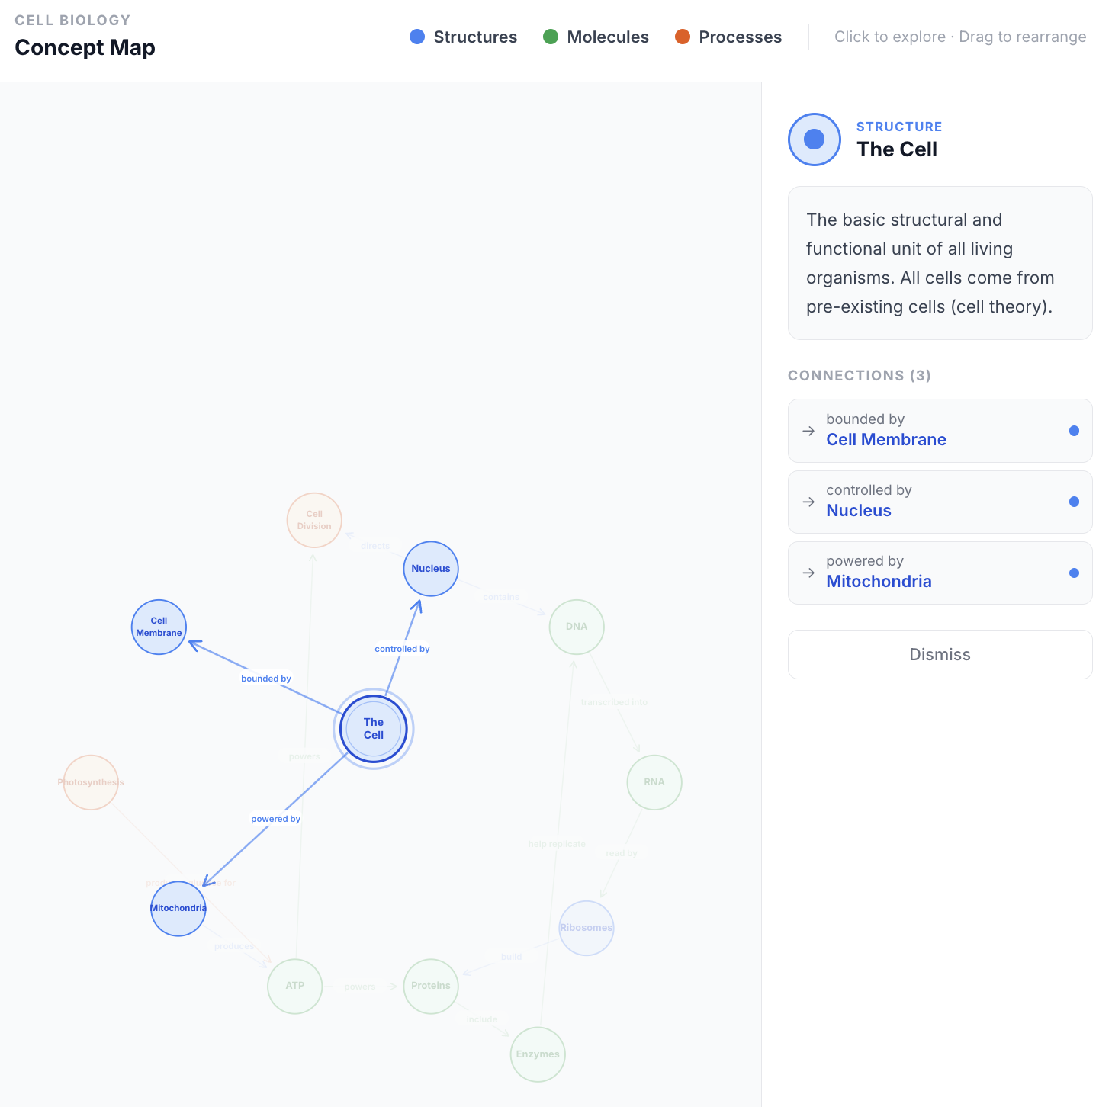
Figure 6. Clicking a node reveals its definition and connections to other concepts. This detail view shows “The Cell” with its three primary connections.

Tutor Mode, Specified: The Six Rules (Make It a Skill)
A good AI tutor is not a vibe; it is six enforceable rules. Written in your own voice, they are also a complete skill file: save them once and every study session starts this way.
1. Retrieval first. “Quiz me before you teach me. Never explain what I have not first attempted.” Practice testing is one of the two highest-utility study techniques in the entire learning literature (Dunlosky et al., 2013); being quizzed strengthens memory more than being told.
2. Socratic. “Answer my question with the question that gets me there. Full solutions only after two real attempts.” This is how effective tutoring actually works: guided questioning, not answer delivery (VanLehn, 2011).
3. Calibration. “Before revealing any answer, ask my confidence. Track it and show me my calibration weekly.” Overconfidence is the metacognitive failure that makes students stop studying too early; measuring it is the fix.
4. Spacing and interleaving. “Bring back last week's material on a schedule. Mix problem types so I cannot run on autopilot.” Distributed practice is the other top-rated technique (Cepeda et al., 2006; Dunlosky et al., 2013), and mixed problem types beat blocked drilling.
5. Teach-back. “Make me explain it back, then grade my explanation against the source.” Self-explanation is the strongest comprehension check a learner can run alone, and the teach-back-grader skill automates the grading.
6. Desirable difficulty. “Keep me at the edge of my ability, not inside my comfort zone.” Learning that feels easy is usually storage without retrieval strength (Bjork); a good tutor keeps productive struggle in the session.
Save it: paste the six rules as tutor-mode/SKILL.md (in Claude: Settings, then Capabilities, then Skills; in any other AI, keep it pasted at the top of study sessions). In AIEM terms, these rules hold you in Tutor and Challenge modes and make the Oracle slide impossible.

Tune the Tutor to You: An Evidence-Based Profile
One tutor does not fit all, but the honest version of that sentence is narrower than the popular one. Learning-styles matching (visual, auditory, kinesthetic) has no adequate supporting evidence; the definitive review (Pashler, McDaniel, Rohrer, & Bjork, 2008) found none. What does have evidence: tuning on prior knowledge, approach to learning, and calibration.
Prior knowledge. If you are new to a topic, the tutor should give worked examples and fade the scaffolding as you improve. If you are advanced, worked examples actually hurt (the expertise-reversal effect; Kalyuga et al., 2003): the tutor should give problems first and hints on demand.
Approach to learning, and the measure you can take today. The R-SPQ-2F (Biggs, Kember, & Leung, 2001) is a 20-item questionnaire, five-point scale, self-scored in ten minutes, free online on John Biggs's site (johnbiggs.com.au). It gives you two scores: deep approach and surface approach. If your surface score is higher, your tutor should enforce retrieval and spacing strictly and tie every topic to your goals. If your deep score is higher, your tutor should add extension, challenge, and transfer problems beyond the syllabus. Treat the scores as a tuning input and a reflection prompt, not a label.
The procedure: 1. Take the R-SPQ-2F, answering about this course specifically, and score both scales per the key on the form. 2. Prompt your AI: “Here are six tutor rules [paste them] and my R-SPQ-2F scores, deep [x] and surface [y]. Write tutor-mode/SKILL.md for [course]: the six rules plus tuning based on my scores. Include WHEN TO USE: every study session for this course.” 3. Save the skill. 4. Remeasure at midterm and let the AI update the tuning. If your instructor assigns this, the deliverable is the SKILL.md plus one session transcript showing the rules held.

5.2 Retrieval Practice and Self-Testing Prompts
Skills: retrieval-session, flashcard-builder, blank-page-test. With the toolkit installed, say "quiz me," "make flashcards," or "give me a blank page test" to run these workflows.
Retrieval practice is the single most effective learning strategy identified in research (Dunlosky et al., 2013). These prompts force you to recall rather than recognize.

Flashcard Generator
PROMPT
Based on [chapter/topic], build me an interactive flashcard app as a visual artifact. Include:
- 20 flashcards that test understanding (not just recall of definitions).
- A mix of difficulty levels: some basic, some that require application, some that require analysis.
- At least 3 "trick" questions where the obvious answer is wrong.
- A card-flip interaction: show the question, let me think, then click to reveal the answer.
- Buttons to mark each card as "got it" or "need to review."
- A progress tracker showing how many I have completed and my accuracy.
- At the end, a summary of which cards I missed and an option to retry just those cards.

Do not just list the flashcards in the chat. Build the interactive app so I can drill through them like real flashcards.

The screenshots below show a sample flashcard app Claude generated for Intro to Psychology. The card flips to reveal the answer, and buttons let you mark each card as mastered or needing review.
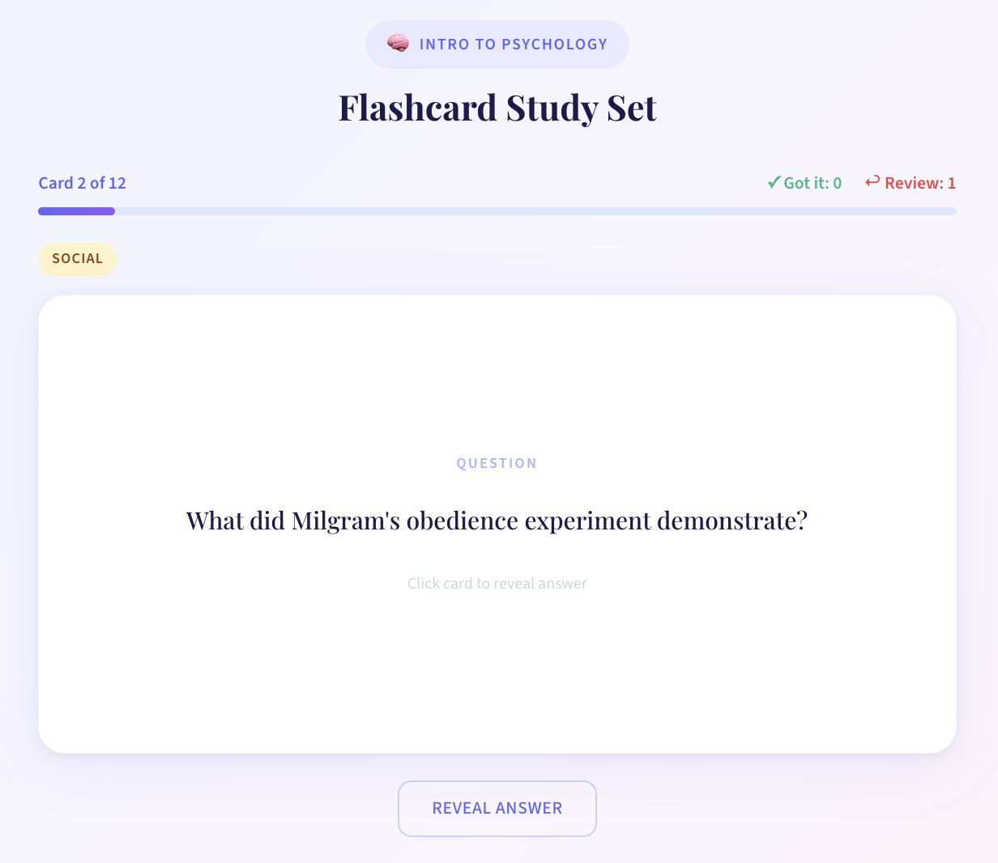
Figure 7. Sample interactive flashcard app: the question side of a psychology flashcard with progress tracking and category labels.

Figure 8. After clicking to reveal the answer, “Review Again” and “Got It” buttons let you sort cards by mastery level.

Spaced Retrieval Session
PROMPT
In our previous study sessions, I struggled with these topics: [list topics from past sessions].

Today, before we cover new material, test me on those weak spots:
1. Ask me 5 questions on material from our last session.
2. Ask me 3 questions on material from 2-3 sessions ago.
3. Ask me 2 questions on material from the beginning of the semester.
4. For any I get wrong, re-teach briefly and flag for next session.
5. Then we can move to today's new material: [topic].

The Blank Page Test
PROMPT
I think I know [topic] well. Prove it or disprove it.

Give me a blank page prompt: "Explain [topic] completely, from scratch, as if you are writing a textbook section. Include definitions, examples, applications, and connections to related concepts."

I will write my explanation. Then you grade it on:
- Accuracy (is everything correct?)
- Completeness (did I cover all the important aspects?)
- Depth (do I understand WHY things work, not just WHAT they are?)
- Connections (did I link this to related concepts?)

Be strict. A professor would be.

5.3 Critical Reading and Analysis Prompts
Skills: active-reader, reading-visualizer. With the toolkit installed, say "walk me through this reading" or "map this argument" to run these workflows.

Active Reading
PROMPT
I need to read [chapter/article/case] for class. Instead of just reading it passively, I want to read actively. After I read each section, I will summarize it to you in my own words. Your job:
1. Check whether my summary is accurate.
2. Ask me "why does this matter?" after each section.
3. Push me to connect each section to the previous ones.
4. At the end of the full reading, ask me: "What is the author's main argument, and do you agree with it? Why or why not?"
5. If I am just summarizing without thinking, call me out on it.

Reading Visualization
After you have worked through a reading actively, ask Claude to build a visual that captures the argument structure. This is more effective than re-reading your notes because it forces you to see the logical architecture.
PROMPT: Reading Argument Map
I just finished reading [chapter/article] and we discussed it. Build me an interactive visual artifact that maps the author's argument:
1. Show the main thesis at the center or top.
2. Branch out to the key supporting arguments and the evidence for each.
3. Show where the author addresses counterarguments (and whether they do it well or poorly).
4. Highlight any assumptions the author makes but does not defend.
5. Let me click on each element to see my notes from our conversation.

Color-code by argument strength: green for well-supported claims, yellow for partially supported, red for weak or unsupported.

Case Analysis
PROMPT
I have a case study to analyze for [course]. Here is the case: [paste or describe].

Do NOT analyze it for me. Instead, guide me through a structured analysis:
1. Ask me: "What is the core problem or decision in this case?"
2. After I answer, ask: "What information in the case is most relevant to this problem? What is noise?"
3. Then: "What are the stakeholders, and what does each one want?"
4. Then: "What are the possible courses of action?"
5. Then: "What criteria should you use to evaluate these options?"
6. Finally: "Make your recommendation and justify it with evidence from the case."

At each step, push back on my reasoning if it is weak.

5.4 Study Planning and Time Management Prompts
Skills: semester-planner, weekly-reset. With the toolkit installed, say "plan my semester" or "do my weekly reset" to run these workflows.

Semester Study Plan
PROMPT
Here are my courses this semester and their major assignments and exams:
[List each course with upcoming deadlines, exam dates, and major assignments]

Help me build a study plan for the next [2 weeks / month / rest of semester]:
1. Identify the highest-priority items based on deadlines, difficulty, and weight in my grade.
2. Distribute study sessions across the weeks. Use spaced repetition: I should study each topic on multiple different days, not cram it all into one session.
3. Allocate more time to courses where I am struggling and less to courses where I am strong.
4. Build in buffer time for unexpected assignments or topics that take longer than planned.
5. Keep each study session to 30-60 minutes focused work. No 4-hour marathon sessions.
6. Include specific activities for each session (not just "study chapter 5" but "do practice problems on chapter 5, sections 3-4, then self-test").

Weekly Reset
PROMPT
It is [day] and I want to plan my study week. Here is where I stand:
- What I accomplished last week: [list]
- What I did not get to: [list]
- Upcoming deadlines this week: [list]
- Topics I still feel weak on: [list]

Reorganize my plan for this week. Be realistic about what I can actually accomplish. If I am behind, tell me what to prioritize and what to let go of for now.

Visual Study Dashboard
A text-based study plan is useful, but an interactive visual makes it easier to see the big picture and adjust on the fly.
PROMPT: Study Dashboard
Build me an interactive study dashboard as a visual artifact for the next [2 weeks / month]. Include:
1. A calendar view showing which topics I am studying on which days.
2. Color coding by course so I can see my balance at a glance.
3. Deadline markers for exams and assignments.
4. A priority indicator for each study session (high / medium / low based on how close the deadline is and how weak I am on the topic).
5. A checkbox or progress tracker I can use to mark sessions as completed.

Base this on the study plan we just created. I want to see my whole schedule visually, not just read it as a list.

Here is what a generated study dashboard looks like. This sample was built for a freshman taking Biology, Statistics, English Composition, and History, with a midterm and several deadlines over a two-week period.
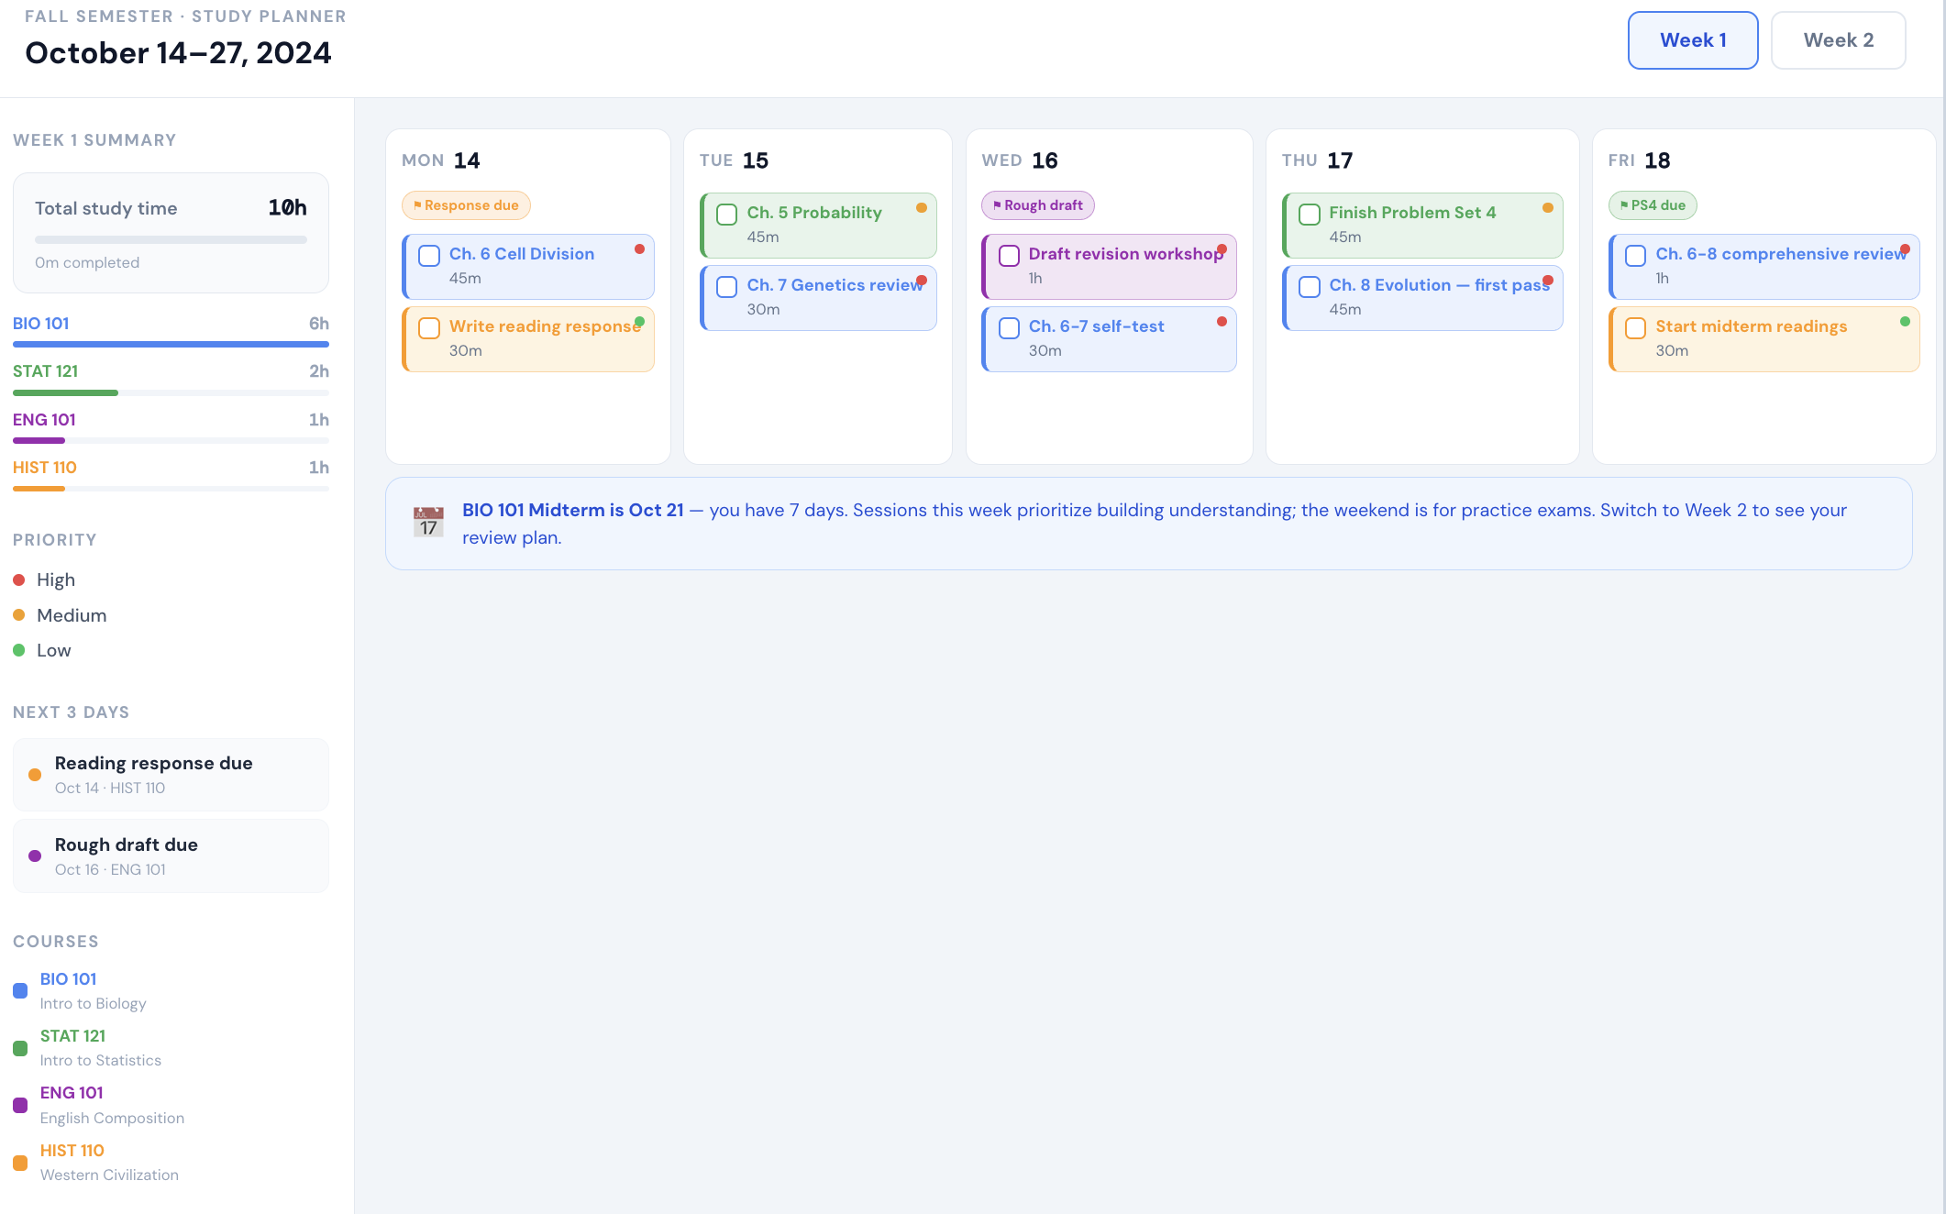
Figure 9. Sample interactive study dashboard showing a two-week planner with color-coded courses, deadline markers, priority indicators, and a summary panel.

5.5 Writing Improvement Prompts
Skills: paragraph-editor, argument-strength-checker, voice-preserver. With the toolkit installed, say "edit this paragraph," "check my argument," or "edit but keep my voice" to run these workflows.

Paragraph-Level Feedback
PROMPT
Here is a paragraph I wrote: [paste paragraph].

Give me feedback on this single paragraph:
1. Is the main point clear in the first sentence?
2. Does every sentence contribute to the paragraph's argument?
3. Is there anything redundant?
4. Is the evidence or support adequate?
5. How is the writing quality? Flag any awkward sentences, unclear phrases, or weak word choices.
6. Rewrite the weakest sentence and explain why your version is better.

Do not rewrite the whole paragraph. Help me learn to improve my own writing.

Argument Strength Check
PROMPT
Here is my argument: [paste the argumentative portion of your paper].

Attack it. Pretend you are a professor who disagrees with everything I wrote:
1. What are the weakest points in my argument?
2. What counterarguments am I not addressing?
3. Where am I making claims without enough evidence?
4. Where am I overgeneralizing from limited evidence?
5. What is the single most devastating critique a reader could make?

Then, after the critique, help me strengthen each weak point. Do not rewrite it for me. Tell me what each section needs, and I will revise.

6. Building Visual and Interactive Learning Tools

6.1 Why Visuals Matter for Learning
Claude can generate interactive learning tools directly in the conversation through its visual interface (called "artifacts"). These include interactive quizzes, concept visualizations, flashcard apps, process diagrams, comparison matrices, and data visualizations. This is one of the most underused capabilities for student learning.
Visual and interactive elements engage different cognitive pathways than text alone. An interactive diagram that you can manipulate teaches differently than a paragraph describing the same relationships. A quiz app that tracks your performance across multiple rounds provides immediate feedback loops that accelerate learning.
The key principle: do not just ask Claude to show you a visualization. Ask Claude to build something interactive that requires your engagement.
The best place to start is by asking Claude what it can build for your specific topic. Claude’s visual capabilities are broad and growing, and the most useful artifact for your situation may not be one you would have thought to request. Before jumping to a specific prompt, try the discovery prompt below.

PROMPT: Discover What Claude Can Build
I am studying [topic] for [course]. I learn best when I can interact with material, not just read about it.

What kinds of interactive visual tools could you build for me on this topic? Think broadly: quizzes, simulations, diagrams, flashcards, calculators, timelines, comparison tools, decision trees, drag-and-drop exercises, data explorers, or anything else that would help me understand and retain this material.

For each idea, give me:
1. What it would look like and how I would interact with it.
2. Why it would help me learn this specific topic (not just any topic).
3. Which AI Engagement Model mode it supports (Tutor, Verification Agent, etc.).

Then ask me which one I want you to build.

This discovery step is worth the 30 seconds it takes. Students who ask Claude what is possible consistently get more useful artifacts than students who jump straight to "make me a quiz." Claude can build simulations, interactive calculators, drag-and-drop exercises, annotated diagrams, and tools you probably have not seen before. Let it suggest options before you commit to one.
The rest of this section provides specific prompts for the most common artifact types. Use them as starting points, but do not treat them as the full menu.

6.2 Interactive Quiz and Flashcard Tools
Skills: flashcard-builder, concept-map-builder. With the toolkit installed, say "build me a flashcard app" or "make a concept map for this topic."

Build a Quiz App
PROMPT
Create an interactive quiz for me on [topic/chapter]. Build it as a visual interface with:
1. Multiple question types: multiple choice, fill-in-the-blank, and short answer.
2. A score tracker that shows my performance as I go.
3. Immediate feedback after each question: if I get it wrong, explain why the correct answer is correct.
4. At least 15-20 questions covering the full range of the material.
5. A final summary showing which topics I got right, which I got wrong, and what I should review.
6. A "retry missed questions" feature so I can practice my weak spots.

Make the difficulty progressive: start easier and get harder as I go.

Concept Visualization
PROMPT
I need to understand [complex concept/process/system]. Create an interactive visual that:
1. Shows the components and how they relate to each other.
2. Lets me click on each component to see a detailed explanation.
3. Shows the flow or sequence if there is one (inputs, processes, outputs).
4. Highlights which parts I should focus on for my exam.
5. Uses color coding to distinguish between different categories or types.

Make it clear enough that I could use it as a study reference.

Comparison Matrix
PROMPT
I need to compare [list of theories/concepts/approaches/methods] for [course]. Create an interactive comparison table that:
1. Lists each item as a row.
2. Includes columns for: key idea, strengths, weaknesses, when to use it, key researcher(s), and how it relates to the others.
3. Lets me sort or filter by different columns.
4. Includes a brief quiz at the bottom that tests whether I can identify which approach fits different scenarios.

6.3 Process and Concept Diagrams

Flowchart Builder
PROMPT
Create a flowchart showing [process/decision tree/workflow]. Include:
1. All the steps in the correct order.
2. Decision points where different paths are possible.
3. Clear labels for what happens at each step.
4. Color coding for different types of steps (decisions vs. actions vs. outcomes).
5. A brief explanation of each step that I can reference while studying.

Timeline Visualization
PROMPT
Create an interactive timeline showing [historical events / theoretical development / process stages] for [course]. Include:
1. Key events or milestones with dates.
2. Brief descriptions of why each matters.
3. Connections between events (cause and effect, influence relationships).
4. Color coding by theme or category.
5. The ability to zoom in on specific periods for more detail.

6.4 Working with Claude’s Visual Output
A note on Claude’s visual artifacts: they are functional but not always polished. Labels may overlap, colors may not be ideal, and layouts may need adjustment. This is normal. The value is in the interactive learning experience, not publication-quality graphics.
When something does not look right, tell Claude specifically what needs fixing. "The labels on the X axis are overlapping" or "The connection between Box A and Box C is missing" gives Claude enough information to fix the issue. For diagrams you want to keep or share, you can ask Claude to generate SVG code that you can import into a professional tool like LucidChart. But for study purposes, the in-conversation artifacts are usually sufficient.

7. Cross-Tool Workflows

7.1 Why Use Multiple AI Tools
Using a second AI as an independent check on the first directly practices Mode 5 (Verification Agent) and Mode 7 (Critical Challenger). The principle is straightforward: a genuinely different model will catch genuinely different issues. Many students have access to Gemini for free through their university Google Workspace accounts, which makes it an ideal second-opinion tool.

7.2 The Second-Opinion Workflow
Three practical uses:
Fact-checking: After Claude explains a concept, ask Gemini the same question and compare the answers. Where do they agree? Where do they differ? The differences are where you need to dig deeper.
Argument testing: After Claude helps you build an argument for a paper, paste the argument into Gemini and ask it to critique. A different model will find different weaknesses.
Study verification: After studying a topic with Claude, test yourself using Gemini. If you can explain the concept to a different AI without your Claude conversation open, you actually understand it.

PROMPT
I have been studying [topic] with another AI tool. Here is the explanation I received and my current understanding:

[Paste your understanding, not the AI's explanation]

Please evaluate my understanding:
1. Is anything I said incorrect or misleading?
2. Is there an important aspect of [topic] that I have not mentioned?
3. Do you have a different perspective on this topic than what I described?
4. What is one thing I should look up to verify independently?

7.3 When to Use Which Tool
Claude is recommended as the primary learning tool because of its visual interface (artifacts), extended thinking, and project-based context. Gemini is excellent for fact-checking (with Google search integration), working within Google Docs and Slides, and getting a second perspective. ChatGPT is strong for code-heavy work, quick general questions, and its extensive plugin ecosystem.
The principle is the same one that applies to the research document: do not use multiple tools for variety. Use them for genuine independent verification.

8. Honest Self-Assessment: Avoiding the Traps

8.1 The Illusion of Understanding (Revisited)
Skills: understanding-checker, mode-diagnostic, ai-tone-detector. With the toolkit installed, run understanding-checker before you assume you've learned a topic, mode-diagnostic to see which engagement mode you're drifting into, and ai-tone-detector to catch AI-confident-tone in your drafts.
Now that you have spent time working through the earlier sections, let me return to the core problem from Section 1.2 with practical tools to combat it. After spending time with AI, students often believe they understand material better than they do. Three concrete tests can help:
The "close the chat" test: Can you explain the concept without any AI assistance? If you need to peek at the conversation, you have recognition, not understanding.
The "teach a friend" test: Can you explain it to someone who knows nothing about the topic? If your explanation is vague or you keep saying "basically, it is like..." without specifics, you are not there yet.
The "next-day" test: Can you still explain it tomorrow? Understanding that evaporates overnight was never real understanding. This is why spaced repetition matters: testing yourself on the same material across multiple days is the most reliable way to build durable knowledge.

8.2 Recognizing When You Are Sliding into Passivity
Practical warning signs that you have slipped from active learning into passive consumption:
- You are reading AI responses without pausing to think about them.
- You have not typed anything substantive in several exchanges (just "ok" or "go on" or "tell me more").
- You could not summarize what you learned in the last 10 minutes.
- You are copying AI output directly into your assignment without rephrasing or restructuring.
- The conversation feels easy. Real learning involves struggle. If it is comfortable, you are probably in Oracle mode.

PROMPT: The Honest Check-In
I have been studying for [duration]. I want an honest assessment of our conversation:
1. Look at my messages in this conversation. What percentage of them were substantive (contained my own reasoning, asked thoughtful questions, challenged something) vs. passive (just asked for information or said "ok")?
2. Based on our interaction, am I in learning mode or consumption mode right now?
3. If I am being too passive, give me a challenge that forces me to actively engage.
4. Ask me to summarize what I have learned in this session without looking at our conversation. (I will scroll up to check after I try.)

8.3 The Confident Tone Trap (for Writing)
When AI helps you write, the output typically sounds more confident than what you would produce on your own. This is often a good thing: clearer, more direct prose. But it can also lead to overclaiming. If your paper says "the evidence clearly demonstrates" when it really only "suggests," that is a problem.
Get in the habit of reading AI-assisted writing and asking: "Would I be comfortable defending every claim in this paragraph to my professor?" If not, soften the language. Keep the confident structure. Just make sure every strong claim is backed by strong evidence.
Also watch for excessive forward references ("as we will see later...") which AI produces more often than natural writing warrants. Either present the information now or let the reader encounter it when they get there. If you find yourself writing "as discussed below" more than once or twice in a paper, that is a sign to reorganize rather than to forward-reference.

9. Academic Integrity and AI Disclosure

9.1 Using AI Honestly
This guide teaches you to use AI as a learning tool, not a cheating tool. The distinction is simpler than most students think:
If AI did the thinking and you submitted the output, that is academic dishonesty in almost every context. If you did the thinking and AI helped you think better, that is a learning tool.
The prompts in this guide are designed to keep you on the right side of this line. They all require your active engagement. But the responsibility is yours. Every university has its own AI use policies, and they differ across institutions and often across individual courses. Know your institution’s policy. Know each professor’s policy (they may vary by class). When in doubt, disclose.
One more honesty tool, because the stakes are concrete: AI models fabricate citations at rates you should know before you ever paste a reference into an assignment. Recent studies put fabrication at roughly 20 to 40 percent for current models writing from memory, over 90 percent for one older model, and the rate spikes on unfamiliar topics and highly specific requests. Even among the genuine citations in one 2025 study, 45 percent contained errors, most often the DOI.
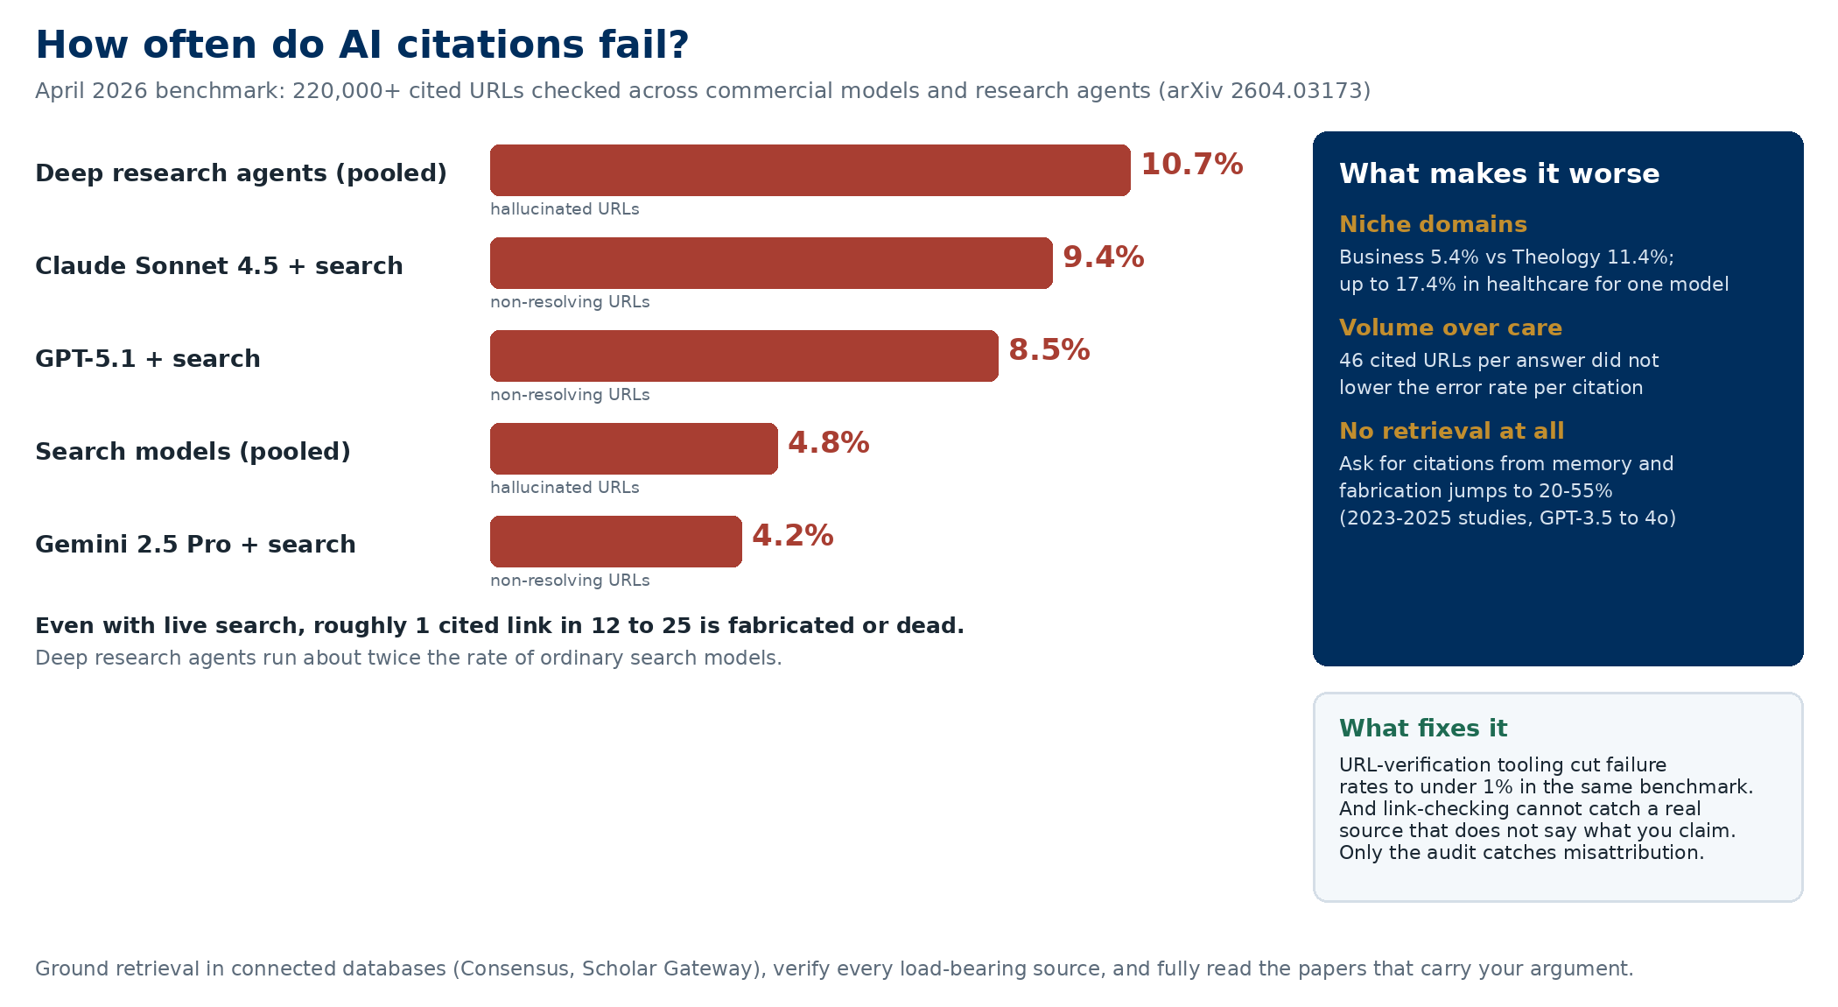
The fix is the same one this guide teaches everywhere: verify before you rely. Ground searches in connected databases rather than the model's memory, check each source against the exact claim you are using it for, and fully read any paper that carries a major point in your work. The source-verifier skill in the toolkit walks you through it.

9.2 How to Disclose AI Use
When disclosure is required (or when you choose to disclose proactively), be specific about what AI did and what you did. Vague statements like "I used AI for this assignment" do not give your professor enough information to evaluate your work. A good disclosure statement is specific and honest.

PROMPT
I used AI assistance in this assignment. Help me write an accurate disclosure statement. Here is what I actually used AI for:
[List specifically: brainstorming, finding sources, checking my reasoning, improving my writing, generating practice problems, etc.]

And here is what I did myself:
[List: developed the thesis, wrote the first draft, made all analytical decisions, chose which sources to include, etc.]

Write a disclosure that is honest, specific, and brief. Do not overstate or understate AI's role.

Skills: disclosure-writer, policy-interpreter. With the toolkit installed, say "draft my AI-use disclosure" or "what does this AI policy actually allow?" to run these workflows automatically.

10. The Learn-with-AI Toolkit Plugin
Everything in this guide — the eight engagement modes, the six entry points, the prompt library, the study session templates, the writing workflows — is now packaged as a single installable toolkit for Claude Cowork. This section explains what skills are, why they matter, how to install the toolkit, and what each of the 59 skills does.

10.1 What Skill Files Are and How They Help
A skill is a small instruction file that teaches Claude a specific workflow. Instead of you remembering and retyping a long prompt every time you sit down to study, write a paper, or review for an exam, Claude recognizes what you are trying to do and automatically runs the matching workflow. You get a consistent workflow without having to re-teach Claude your preferences every session.

How a skill works, step by step:
A skill file is just a folder with a short Markdown file inside it (SKILL.md). The file has a name, a description of when to use it, and the instructions Claude should follow when that skill is triggered. When you install the Learn-with-AI Toolkit, all 59 skill folders get added to Claude. Then, whenever you type something like "help me prep for my midterm" or "build me flashcards for this chapter," Claude scans the skill descriptions, matches your request to the right skill, and loads its workflow before responding. You do not have to name the skill — Claude picks it for you.

Why skills help students specifically:
1. They encode good practice. The skills in this toolkit bake in retrieval practice, spaced repetition, Socratic tutoring, and the other evidence-based techniques this guide describes. Even if you forget the principles, the skill does not.
2. They save time and tokens. A good study prompt from this guide can run 300 words long. You do not have to paste it every session — the skill holds it for you. That means shorter messages on your end and faster responses from Claude.
3. They support modes that fit learning. Each skill is designed around the principle from Section 2 of this guide: Claude coaches, and you do the thinking. The skills use questions, checks for understanding, and deliberate friction when the learning goal requires them.
4. They compose. A single study session might chain three skills: first active-reader walks you through the chapter, then retrieval-session quizzes you on it, then teach-back-grader tests whether you really understand it. You do not manage the chain; Claude does.
5. They are discoverable. When you are not sure where to start, the master orchestrator skill (learn-with-ai) asks what you are working on and routes you to the right stage-specific skill. Think of it as a front desk for the whole toolkit.

In short: skills turn this guide from a book you have to remember into a set of tools that run themselves when you need them. You keep doing the thinking. Claude handles the structure.

10.2 How to Install the Toolkit
You install the toolkit once, and Claude Cowork remembers it across all your future sessions.

Step 1: Download the plugin file.
Go to https://aimodes.ai/learn-with-ai-toolkit.plugin and save the file to your computer. (Keep the .plugin extension intact — do not let your browser rename it to .zip.)

Step 2: Open Claude Desktop in Cowork mode.
If you have not set up Cowork mode yet, see Section 3 ("Setting Up Your AI Learning Environment") first.

Step 3: Install the plugin.
In the Claude app, go to the plugin settings (Settings → Plugins in Cowork mode), click "Install from file," and choose the learn-with-ai-toolkit.plugin file you just downloaded. Claude will install all 59 skills and confirm when it is done.

Step 4: Verify.
Start a new conversation and type: "Which learn-with-ai skills are installed?" Claude should list them. Or try: "I have 30 minutes to study — set me up." Claude should load the study-session-planner skill and walk you through a session.

Download link (same as above): https://aimodes.ai/learn-with-ai-toolkit.plugin

Using Codex instead of Claude? The same 59 skills ship as a Codex package at the same aimodes.ai link: learn-with-ai-skills-codex.zip. The easiest install is to let Codex do it: download the zip, open Codex, and paste, 'Install the skills from the zip file called learn-with-ai-skills-codex.zip in my Downloads folder into your skills folder at ~/.codex/skills, one folder per skill, then list the skills you loaded.' Codex sets everything up and confirms. Prefer to do it by hand? A README inside the zip walks through it click by click with Finder or File Explorer, no terminal needed. The skills behave the same in either tool.

10.3 The 59 Skills at a Glance
The toolkit is organized into 14 categories that mirror the structure of this guide. You do not need to memorize any of these — Claude will match your request to the right skill automatically. This catalog is here so you can see the full range of what the toolkit can do.

Core Study and Retention (8 skills)
study-session-planner — "I have X minutes and these materials — build me a session." Structures retrieval, active recall, and self-test (encodes Entry Point A).
socratic-tutor — Dialogic concept teaching. Claude asks leading questions; you produce the answers.
teach-back-grader — Explain a concept to Claude; it probes gaps and grades understanding, not fluency.
retrieval-session — Runs a spaced retrieval quiz that adapts to what you get wrong. Tests connections, not definitions.
flashcard-builder — Generates an interactive HTML flashcard app from your course material.
blank-page-test — No-materials recall test. Reveals what you actually know vs. what you thought you knew.
concept-map-builder — Interactive concept map that forces you to see structural relationships.
misconception-hunter — Probes the classic misconceptions in a topic before they bite you on the exam.

Reading and Notes (3 skills)
active-reader — Walks you through a reading section by section with comprehension checks at each one.
reading-visualizer — Builds a diagram of the argument structure of a paper or chapter.
note-restructurer — Takes messy class notes and converts them into structured study material.

Exam Preparation (4 skills)
exam-blueprinter — Syllabus + past exams + assignments → exam blueprint and study priorities.
practice-exam-generator — Generates a full mock exam matched to your course's exam format.
spaced-exam-plan — Multi-week study plan with spaced retrieval built in.
exam-post-mortem — Reviews what went wrong on a returned exam and targets your future studying.

Writing Papers (8 skills)
paper-outliner — Assignment + thesis → full outline with evidence slots.
thesis-sharpener — "Is this thesis strong enough?" — specific, arguable, and supportable test.
evidence-collector — For each claim in your draft, suggests what evidence or citation you need.
paragraph-editor — Targeted paragraph-level feedback on clarity, flow, and argument.
argument-strength-checker — Pressure-tests your argument for holes before you submit.
voice-preserver — Edits your draft while keeping your voice — counters the "confident AI tone" trap.
citation-formatter — APA, MLA, or Chicago formatter with bibliography cross-check.
source-verifier — Verifies the citations, quotes, and claims in AI output before they go into coursework: confirms sources exist in real databases, checks each source against the claim it supports, and reads the full paper for anything load-bearing.
writing-tone-card — Builds a student-specific tone card so Claude's suggestions match your voice.

Problem Sets (STEM) (5 skills)
problem-coach — Coach through a problem: understand, plan, solve. Claude guides; you compute.
worked-example-generator — One worked example + one parallel unsolved practice problem.
derivation-walker — Step-by-step derivation walk-through with comprehension checks.
proof-coach — You write the proof; Claude checks and asks leading questions without giving the answer.
error-teacher — Error in math or code → Claude teaches you to find it, not fix it for you.

Coding Assignments (4 skills)
code-explainer — Explain what code does at a specific level of depth (line, function, architecture).
code-reviewer-teacher — Review your code like a TA would — teach, don't fix.
assignment-scaffolder — Assignment spec → function list, test plan, pseudocode.
debug-coach — Coach through debugging instead of handing you the fix.

Projects (2 skills)
project-scoper — From idea to realistic scope, timeline, and learning goals.
project-planner — Breaks a project into tasks, dependencies, and milestones.

Graduate-Specific (4 skills)
lit-review-coach — Learning a field through a literature review (distinct from the research-focused skill in the faculty toolkit).
qualifying-exam-prep — Quals / orals prep across subfields with mock committee questions.
seminar-paper-writer — The distinctive graduate-school short-paper form (15–25 pages, theoretical).
thesis-proposal-drafter — Drafting an MS or PhD thesis proposal.

Self-Assessment and Metacognition (3 skills)
understanding-checker — Honest self-test: do you really understand this, or just recognize it?
mode-diagnostic — Tells you which of the eight engagement modes you are currently operating in.
ai-tone-detector — Reads your draft for AI-confident-tone giveaways so you can fix them.

Time and Life Management (3 skills)
semester-planner — Whole-semester strategic plan across all your courses.
weekly-reset — Sunday / Monday planning session.
burnout-coach — Recognizes burnout signs and suggests recovery strategies (without being preachy).

Academic Integrity (2 skills)
disclosure-writer — Drafts an AI-use disclosure for an assignment based on what you actually did.
policy-interpreter — Paste a syllabus AI policy — Claude explains in plain language what's allowed.

Career and Transition (4 skills)
resume-improver — Tunes your resume to a specific target role.
cover-letter-drafter — Job or internship cover letter.
grad-school-application-coach — Statement of purpose, personal statement, application CV.
internship-finder — Matches internships to your profile and crafts tailored applications.

Discipline-Specific (7 skills)
language-learner — Structured practice for learning a second (or third) language.
case-brief-builder — Law, business, and medical case briefs in the standard formats.
clinical-reasoning-coach — Medical / nursing / allied health clinical reasoning practice.
stats-concept-tutor — Conceptual stats tutoring that insists on intuition before formulas.
software-learner — Learning a new piece of software (Excel, R, Stata, SPSS, etc.) hands-on.
lab-report-writer — Structured lab report writing (intro, methods, results, discussion).
lesson-plan-builder — Lesson planning for education / teaching students or future-teacher programs.

Master Orchestrator (1 skill)
learn-with-ai — When you are not sure where to start, ask "help me plan my learning" and the orchestrator routes you to the right stage-specific skill.

10.4 How to Invoke Skills (You Don't Have to Memorize Any of Them)
Skills are designed to trigger on plain-English requests. You do not need to know the skill name. Claude reads your message, matches it to the right skill, and runs the workflow. Here are some example triggers and the skills they activate:

"I have 30 minutes to study — help me make it count." → study-session-planner
"Quiz me on chapter 7." → retrieval-session
"Build me flashcards for this material." → flashcard-builder
"I'm going to teach you this topic and you tell me where I'm weak." → teach-back-grader
"Walk me through this reading." → active-reader
"My midterm is in two weeks — what should I prioritize?" → exam-blueprinter
"Make me a practice exam." → practice-exam-generator
"Help me outline my paper." → paper-outliner
"Is my thesis strong enough?" → thesis-sharpener
"Edit this paragraph but keep my voice." → voice-preserver
"Coach me through this problem — don't solve it." → problem-coach
"My code isn't working — help me debug it." → debug-coach
"Plan out my whole semester." → semester-planner
"Help me write my AI-use disclosure." → disclosure-writer
"What does my professor's AI policy actually allow?" → policy-interpreter
"I'm not sure where to start." → learn-with-ai (orchestrator)

If a skill does not trigger when you expect it to, you can always invoke it by name: "Use the retrieval-session skill on this material." Claude will load it explicitly.

10.5 Pairing with the Faculty Research Toolkit (For Graduate Students)
If you are a graduate student doing empirical research, install the faculty-research-toolkit too. It has 47 research-lifecycle skills (theory building, preregistration, SEM, reviewer simulation, R&R response, and more) that are complementary to this toolkit rather than overlapping.

Use the Learn-with-AI Toolkit for:
Learning the material in your classes, qualifying exams, seminar papers, and coursework.

Use the Faculty Research Toolkit for:
Doing original research — designing studies, running analyses, writing manuscripts, and responding to reviewers.

Download the research toolkit: https://aimodes.ai/faculty-research-toolkit.plugin

Both toolkits can be installed in the same Claude Cowork setup. Claude will pick the right skill for whichever task you are on: a late-night study session or a 2 a.m. revision of a manuscript.

10.6 Updates and Feedback
The toolkit will change as student workflows do. Check https://aimodes.ai/learn-with-ai-toolkit.plugin periodically for updated versions. If a skill is not working as you expect, or if you have a workflow you wish were a skill, email feedback to mark_keith@byu.edu — the roadmap for v1.1 will be shaped by what students actually use and what is missing.

11. References
Anderson, L. W., & Krathwohl, D. R. (Eds.). (2001). A taxonomy for learning, teaching, and assessing: A revision of Bloom’s taxonomy of educational objectives. Longman.
Barr, N., Pennycook, G., Stolz, J. A., & Fugelsang, J. A. (2015). The brain in your pocket: Evidence that smartphones are used to supplant thinking. Computers in Human Behavior, 48, 473–480.
Bloom, B. S., Engelhart, M. D., Furst, E. J., Hill, W. H., & Krathwohl, D. R. (1956). Taxonomy of educational objectives: The classification of educational goals. Handbook I: Cognitive domain. David McKay.
Chi, M. T. H., & Wylie, R. (2014). The ICAP framework: Linking cognitive engagement to active learning outcomes. Educational Psychologist, 49(4), 219–243.
Costa, P. T., & McCrae, R. R. (1992). Revised NEO Personality Inventory (NEO PI-R) and NEO Five-Factor Inventory (NEO-FFI) professional manual. Psychological Assessment Resources.
Dell’Acqua, F., McFowland, E., Mollick, E. R., Lifshitz-Assaf, H., Kellogg, K., Rajaman, S., ... & Lakhani, K. R. (2023). Navigating the jagged technological frontier: Field experimental evidence of the effects of AI on knowledge worker productivity and quality. Harvard Business School Working Paper No. 24-013.
Dunlosky, J., Rawson, K. A., Marsh, E. J., Nathan, M. J., & Willingham, D. T. (2013). Improving students’ learning with effective learning techniques: Promising directions from cognitive and educational psychology. Psychological Science in the Public Interest, 14(1), 4–58.
Ericsson, K. A., Krampe, R. T., & Tesch-Romer, C. (1993). The role of deliberate practice in the acquisition of expert performance. Psychological Review, 100(3), 363–406.
Flavell, J. H. (1979). Metacognition and cognitive monitoring: A new area of cognitive-developmental inquiry. American Psychologist, 34(10), 906–911.
Lee, H.-P., Sarkar, A., Tandon, A., Lam, M. S., & Sellen, A. (2025). The impact of generative AI on critical thinking: Self-reported reductions in cognitive effort and confidence effects. CHI 2025.
Parasuraman, R., & Manzey, D. H. (2010). Complacency and bias in human use of automation: An attentional integration. Human Factors, 52(3), 381–410.
Programs.com. (2025). New data: 92% of students use AI. Programs.com Research.
Risko, E. F., & Gilbert, S. J. (2016). Cognitive offloading. Trends in Cognitive Sciences, 20(9), 676–688.
Schon, D. A. (1983). The reflective practitioner: How professionals think in action. Basic Books.
Sparrow, B., Liu, J., & Wegner, D. M. (2011). Google effects on memory: Cognitive consequences of having information at our fingertips. Science, 333(6043), 776–778.

Appendix A: The AI Engagement Model Quick Reference
Print this page or save it as a quick reference. The eight modes are organized by behavioral grouping, with an example prompt for each.

# | Mode | Example Prompt | Behavioral grouping
1 | Oracle | "What is the answer to this question?" | Passivity
2 | Production Assistant | "Write this / Summarize that" | Passivity
3 | Tutor | "Help me understand. Ask me questions." | Partnership
4 | Collaborative Problem-Solver | "Here is my thinking. What am I missing?" | Partnership
5 | Verification Agent | "Check my work. What errors am I making?" | Agency
6 | Creative Expander | "Five approaches I have not considered?" | Agency
7 | Critical Challenger | "Attack my argument. Where is it weakest?" | Agency
8 | Problem Setter | "Am I even asking the right question?" | Agency

Appendix B: Course Setup Checklist
Use this checklist at the beginning of each semester for every course:
Install the Learn-with-AI Toolkit Plugin from aimodes.ai (see Section 10) — do this once per computer, not per course
- Create a new Claude project named "[Course Name] - [Semester]"
- Upload your syllabus
- Upload textbook chapters or key readings
- Upload past exams or practice problems (if available)
- Upload assignment descriptions as they are assigned
- Add custom instructions using the template from Section 3.2
- Run a test conversation to confirm your materials are accessible
- Upload this guide to your project so Claude understands the learning framework

Appendix C: The 30-Minute Study Session Template
Skill: study-session-planner. This template is encoded in the study-session-planner skill. With the toolkit installed, say "I have 30 minutes — help me make it count" and the workflow below runs automatically.
Print this and keep it at your desk. Follow it every time you sit down for a focused study session.

Time | Activity
Minutes 0–2 | Tell Claude what you are studying and what you already know about it.
Minutes 2–20 | Active learning: Socratic questioning, problem-solving, or concept building. Stay in Mode 3 (Tutor) or Mode 4 (Collaborative Problem-Solver).
Minutes 20–25 | Self-test: Claude asks YOU questions. No peeking at the conversation.
Minutes 25–28 | Review what you got wrong. Brief re-teaching on weak spots.
Minutes 28–30 | Summarize what you learned out loud. Plan what to study next session.

The rule: if you did not test yourself at minute 20, the session does not count. Recognition is not understanding. Prove it.

Appendix D: Sample Custom Instructions for Different Course Types
Copy and paste these into the custom instructions field of your Claude project. Modify the bracketed sections for your specific course.

D.1 STEM Courses
Skills: problem-coach, stats-concept-tutor, derivation-walker, error-teacher. With the toolkit installed, these skills automate the STEM workflows in this guide.
PROMPT: STEM Course Instructions
You are my learning partner for [STEM Course Name]. Focus on building my problem-solving ability, not giving me answers.

Rules:
1. When I present a problem, ask me to identify what type of problem it is before we start solving.
2. Never solve a problem for me. Walk me through it one step at a time, and only reveal the next step after I have attempted the current one.
3. When I make a computational error, do not correct it. Ask me to double-check that specific step.
4. After solving each problem, ask: "What general principle does this problem illustrate?" and "How would you recognize a similar problem on an exam?"
5. Periodically give me a problem with a twist that tests whether I am applying formulas blindly or actually understanding the concepts.
6. If I ask for a formula, ask me to derive it or explain why it works before we use it.

My current level: [beginner / intermediate / advanced].
Topics we are covering: [list].

D.2 Writing-Intensive Courses
Skills: paper-outliner, thesis-sharpener, voice-preserver, paragraph-editor, argument-strength-checker. With the toolkit installed, these skills automate the writing workflows in this guide.
PROMPT: Writing Course Instructions
You are my learning partner for [Writing Course Name]. Help me become a better writer and thinker, not a better delegator.

Rules:
1. Never write more than one paragraph for me. Your job is to help me find and develop MY arguments.
2. When I share a draft, critique it honestly. Tell me where the argument is weak, where the evidence is thin, and where the writing is unclear.
3. After I write something, ask me: "What is the single strongest point in this paragraph?" and "What is the weakest?"
4. Help me find counterarguments to my own position. I need to address them before my professor does.
5. When improving my writing, show me a revised sentence and explain WHY it is better. Do not just rewrite entire sections.
6. Push me to be specific. If I write "many scholars argue," ask me "which scholars? What exactly do they argue?"

My writing goals: [clarity / argumentation / evidence use / style / all of the above].
Current assignment: [describe].

D.3 Case-Based Courses
Skills: case-brief-builder, argument-strength-checker. With the toolkit installed, these skills automate case analysis and argument-strength review.
PROMPT: Case-Based Course Instructions
You are my learning partner for [Case-Based Course Name]. Help me develop my analytical and decision-making skills through case analysis.

Rules:
1. Never give me a case analysis. Guide me through the analysis framework step by step.
2. When I identify the problem, challenge me: "Is that the real problem, or a symptom of something deeper?"
3. Force me to consider stakeholders I might be ignoring.
4. When I propose a solution, ask for my second and third choices. Then ask me to argue for each one before committing.
5. After each analysis, ask: "What framework did you use? Could a different framework yield a different conclusion?"
6. Occasionally play devil's advocate for the option I rejected. Make me defend my decision rigorously.

My current level: [beginner / intermediate / advanced] in case analysis.
Frameworks we are studying: [list].

D.4 Quantitative and Statistics Courses
Skills: stats-concept-tutor, derivation-walker, software-learner. With the toolkit installed, these skills automate quantitative learning workflows.
PROMPT: Quantitative Course Instructions
You are my learning partner for [Statistics/Quant Course Name]. Focus on building my intuition for statistical concepts, not just my ability to compute.

Rules:
1. When I calculate something, ask me to interpret the result in plain language before moving on. "What does this number actually mean?"
2. If I use a statistical test, ask me WHY that test is appropriate. What assumptions does it make? Are those assumptions met?
3. Never just give me the formula. Ask me what each component represents and why it is there.
4. When I get a result, ask: "Is this result surprising? What would it mean if you got the opposite result?"
5. Help me distinguish between statistical significance and practical significance.
6. If I am just plugging numbers into formulas without understanding, stop me and ask me to explain the concept without math first.

Software we use: [R / Python / SPSS / Excel / Stata].
Topics we are covering: [list].

D.5 Reading-Heavy Courses
Skills: active-reader, reading-visualizer, note-restructurer. With the toolkit installed, these skills automate reading and note workflows.
PROMPT: Reading-Heavy Course Instructions
You are my learning partner for [Course Name]. Help me engage deeply with the readings rather than just getting through them.

Rules:
1. When I summarize a reading, ask: "What is the author's main argument, and do you agree?" Do not let me off the hook with a surface-level summary.
2. Push me to connect readings to each other. "How does this author's argument relate to what we read last week?"
3. When I say I understand something, test me. Ask me to apply the author's framework to a new example.
4. Help me distinguish between what the author says and how I interpret it. Push me to be precise about both.
5. When I am preparing for discussion, help me generate questions that go beyond "what did the author say" to "what are the implications and limits of the argument."
6. Challenge me to find the weakest point in every reading, even ones I agree with.

This semester's authors/texts: [list key ones].
Discussion format: [seminar / lecture / online posts / response papers].

